Eddie Johnson Sr.
April 7, 1954 – August 28, 2011

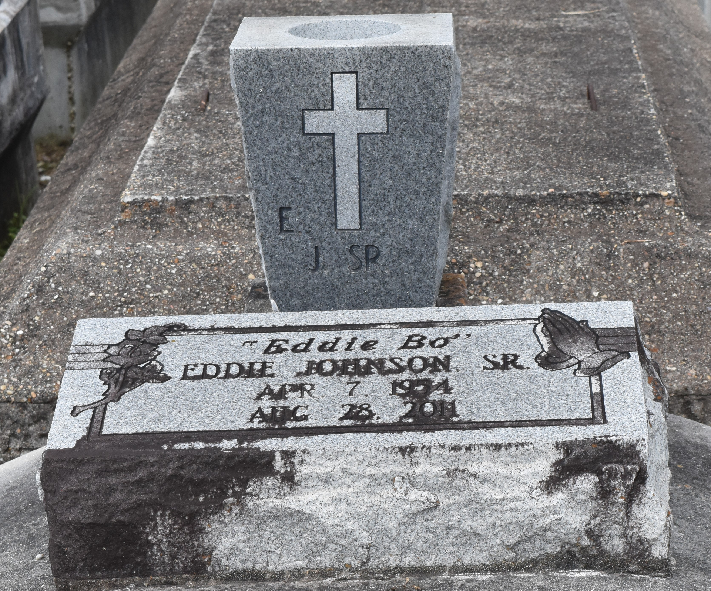

Eddie "Eddie Bo" Johnson, Sr. departed this earthly life on Sunday, August 28, 2011 at his residence in Lutcher, LA.
Son of the late Mathilda R. and Freddie Johnson, Sr. Beloved husband of Gaynell Barconey Johnson of Lutcher, LA. Loving father of Catina J.H. II, Latricia J. (Ivan) McKeel and Minister Eddie "LaVonne" Johnson, Jr. Adopted son of Willie Mae Douglas, son-in-law of Illinois Barconey Jr. and the late Mabel L. Barconey. Also survived by 6 brothers, 4 sisters, 5 brothers-in-law, 5 sisters-in-law, 2 aunts, 2 uncles, 1 aunt-in-law, 3 uncles-in-law, 12 grandchildren, 4 god-children, other relatives and friends.
Relatives and friends of the family, also pastors, officers and members of the Greater Evergreen Baptist Church of Paulina, LA, Third Rose of Sharon Baptist Church, Greater Good Hope Baptist Church, Fresh Faith Temple Church and all neighboring churches are invited to attend the funeral services on Saturday, September 10, 2011 at 11:00 AM at the Greater Evergreen Baptist Church, 3762 Layy, Paulina, LA. Rev. Nolan Albert officiating. Internment in Antioch Cemetery of Paulina, LA. Visitation will be from the above named church from 9:00 AM until service time. Bardell's Mortuary of Mt. Airy, LA in Charge. Information: 985-535-6837.
The Times-Picayune (New Orleans, LA)
September 9, 2011

