Enola Johnson
April 12, 1912 – October 13, 2002

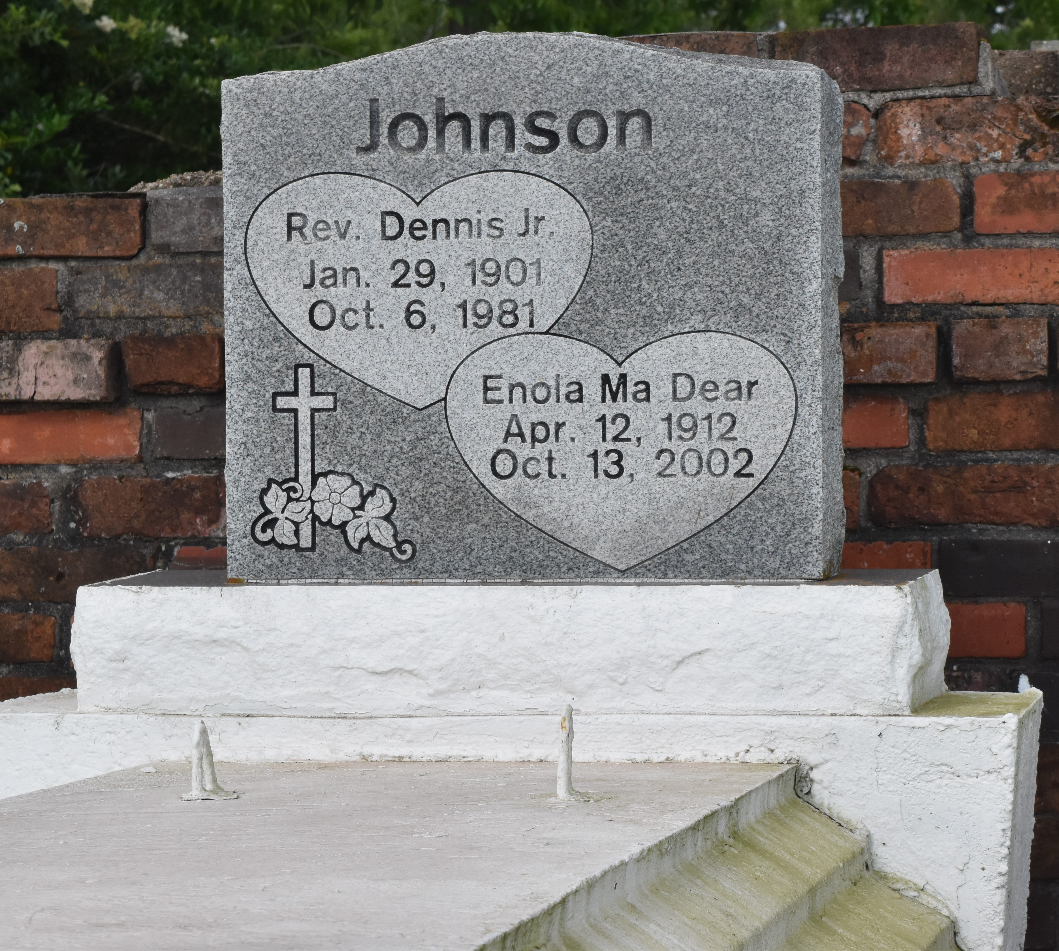

Enola ''Ma Dear'' Johnson departed this Earthly Life and entered into Eternal Rest on Sunday October 13, 2002 at St. James Parish Hospital Lutcher, LA.
Wife of the late Rev. Dennis Johnson Jr. Loving Mother of Ronald Johnson, Faye Farlough of Laplace, LA., Dennis Johnson III of Gramercy, LA., Hattie LaDay, Donald Johnson, and Denese Washington of Lutcher, LA. Mother-in-law of Carol Johnson, Linda Johnson, Naylon Farlough and Earnest LaDay. Sister of Margie Jackson of Ponchatoula, LA and Aldrich Seals of Hammond, LA. Niece of Aurelia Seals of Lutcher, LA. A Devoted Cousin of Marion Scott. A Special Friend of Ora Belle Bazile, Lillian Price, Florence Turner and Lawrence Gordon. Also survived by 9 grandchildren, 13 great-grandchildren, nieces, nephews and many loving Friends. Age 90 years.
Relatives and Friends of the Family also Pastors, Officers, and Members of the King Solomon Baptist Church of Lutcher, LA. and all neighboring churches, employees of South LA. Port Commission, St. John Parish School Board, LaFarge Inc., Nalco Chemical and River Parish Vault are invited to attend the Funeral Services on Saturday October 19, 2002 at 11:00 A.M. at the King Solomon Baptist Church, 2385 Courseault St. Lutcher, LA. Dr. Benjamin Scott Officiating. Interment in Antioch Cemetery Paulina, LA. Wake Services Friday night October 18, 2002 at 7:00 P.M. at the King Solomon Baptist Church Lutcher, LA. Bardell's Mortuary of Mt. Airy, LA in charge. Information 985-535-6837.
The Times-Picayune (New Orleans, LA)
October 18, 2002

