Eva Iris Johnson
July 1, 1946 – March 3, 2013

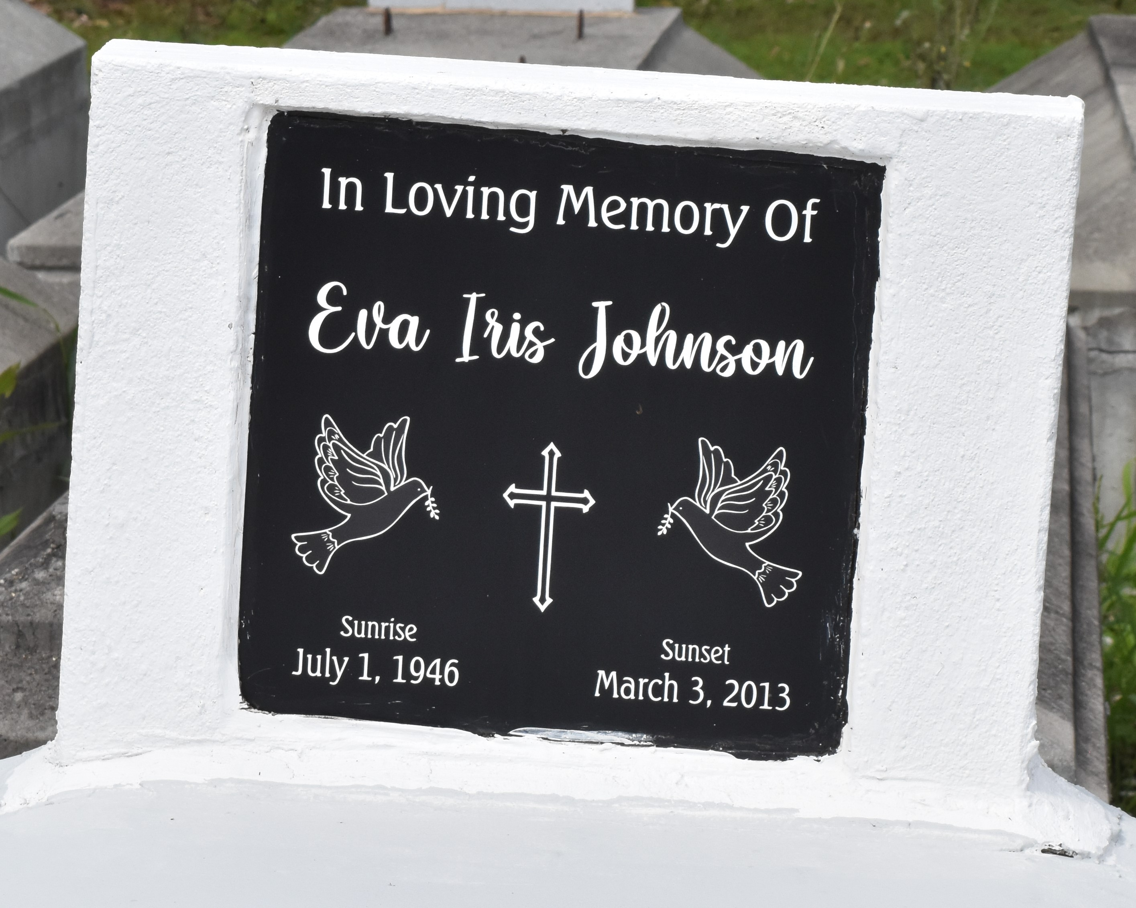

Eva Iris Johnson passed away on Sunday March 3, 2013, Mother of Antoinette Johnson, grandmother of Devin Johnson also survived by a host of other relatives and friends.
Services will be held on Saturday March 09, 2013 at 12:00 noon at Kingdom Hall of Jehovah's Witness 2963 Admiral Landing Street, Pauline, La., Brother Milton Douglas officiating. Internment in Antioch cemetery Paulina, La Services Entrusted to Hobson Brown Funeral Home 134 Daisy St. Garyville, La 70051 985-535-2516.
The Times-Picayune (New Orleans, LA)
Mar. 7 to Mar. 8, 2013

