Ruby Mae (Ponds) Johnson
April 15, 1928 – November 23, 2021

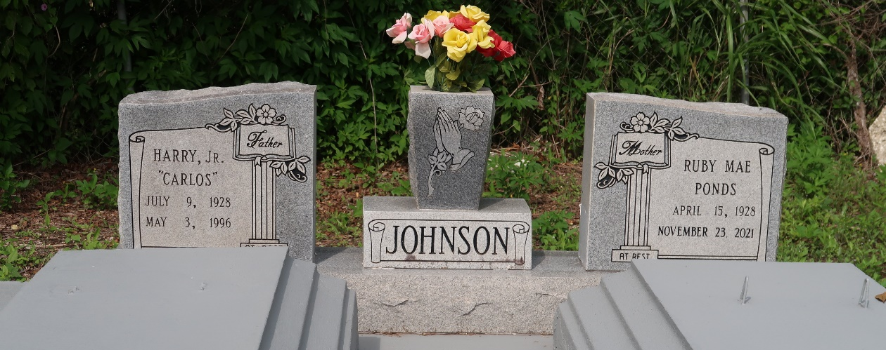

Ruby Mae Johnson passed away peacefully on Tuesday, November 23, 2021 at the age of 93. Daughter of the late Richard Pete and Lottie Miller Ponds. Wife of the late Harry "Carols" Johnson Jr. Mother of Harry, III. Gerald, Caster, Tyrone, Carl, and Sandra Johnson, Elaine Kirklin, Joann Andrus, Lisha Brown, and the late Warren Michael Johnson and Barbara J. Hall. Devoted cousin of Freddie "Man" Miller Jr., Louise M. Washington, Mary M. Joseph, and the late Dorothy M. Banks, Edward Miller and Doretha M. Armont. Ruby is survived by grandchildren, great-grandchildren, great-great-grandchildren, a host of nieces, nephews, great nieces, and great nephews, other relatives and friends.
Funeral Service will be held on Friday, November 26, 2021 at 10:00 am at Mt. Olive B.C., 3143 Hwy 642, Paulina, La. Visitation from 8 am until service time. (Only) Interment Antioch Cemetery, Paulina, LA, Rev. Oscar Nelson officiating. Due to CDC (COVID-19) restrictions, seating may be limited, mask and social distancing are required. Professional services entrusted to the caring staff of Hobson Brown Funeral Home, 134 Daisy St., Garyville, La. 70051, 985-535-2516.
Times-Picayune, New Orleans, Louisiana
Nov. 23 to Nov. 26, 2021

