Warren Michael Johnson
October 23, 1955 – December 14, 2002

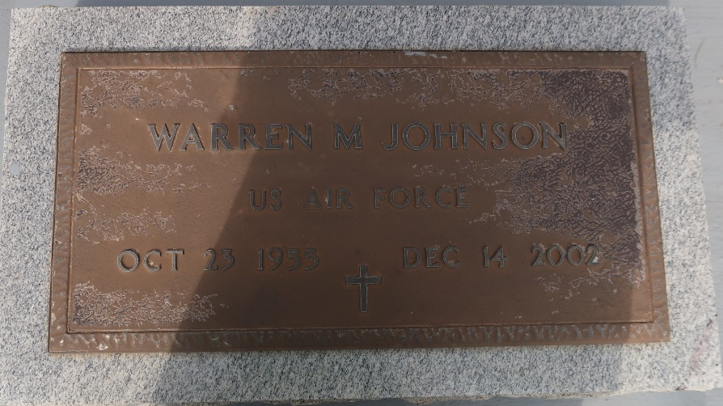

Warren Michael Johnson, a process operator for Shell/Motiva LLC Enterprises, died Dec. 14 of a heart attack at Meadowcrest Hospital in Gretna. He was 47. Mr. Johnson was born in New Orleans and lived in LaPlace. He attended Lutcher High School and was a member of the Air Force for four years.
Survivors include his wife, Maureen Ross Johnson; his mother, Ruby Johnson; three sons, Jared Johnson, Brandon Williams and Jonathon Nelson; two daughters, Shannon Johnson and Taleisha Jacques; seven brothers, Harry, Gerald, the Rev. Castor, Tyrone and Carl Johnson, and Robert and Ricky Ross; and five sisters, Barbara Hall, Sandra Johnson, Elaine Kirklin, Joanne Andrus and Lisha Johnson.
A funeral will be held Saturday at 11 a.m. at Mount Olive Baptist Church on Grandpoint Road in Paulina. Visitation will begin at 9 a.m. Burial will be in Antioch Cemetery in Paulina. Hobson Brown Funeral Home is in charge of arrangements.

Times-Picayune, The (New Orleans, LA)
Friday, December 20, 2002

