Dorothy Mae Joseph
November 1935 – December 8, 2005

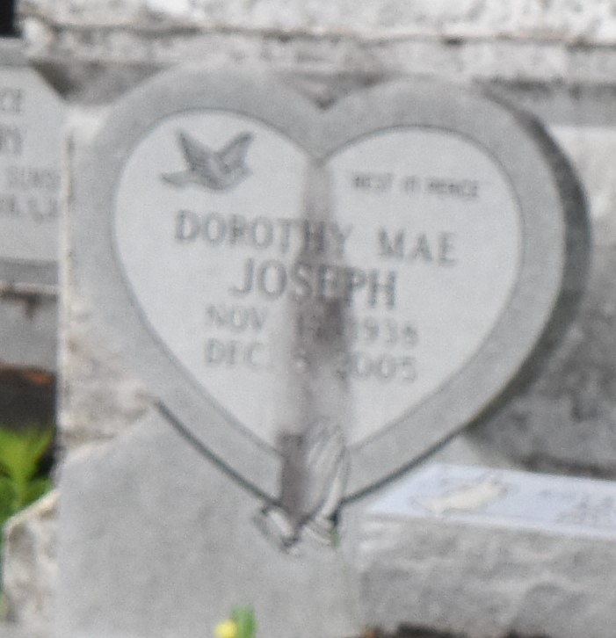

Dorothy Joseph at Doctor's Hospital Parkway, Houston, TX on Thursday, December 8, 2005.
Daughter of the late Ernest Joseph Sr., and Ethel Starks Joseph. Mother of Cheryl Woodard, Cassandra Coney and Catasha Joseph. Sister of Jacqueline Mills, Stella French, Andrew, Jackie and Ernest Joseph Jr. and the late Ernest Joseph, Jr. Grandmother fo Brittany and Jordan Woodard and Zachary Coney. Mother-in-law of Gregory Woodard and Steve Coney. Sister- in-law of Madeline, Lena Mae and Patricia Joseph. Also survived by numerous nieces, nephews, cousins, other relatives and friends. Age 67.
Visiting at Mt. Olive Baptist Church, 3143 Highway 642, Paulina, LA., Saturday Dec. 17, 2005 from 9:30 a.m. until religious services at 11:00 a.m. conducted by the Rev. Elmo Lee. Interment in Antioch Cemetery in Paulina, LA. Brazier-Watson Funeral Home In Charge of Arrangements
The Times-Picayune (New Orleans, LA)
December 16, 2005

