Jackie Joseph
June 10, 1954 – April 25, 2007

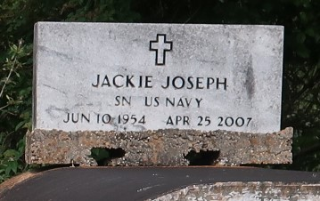

Jackie Joseph on Wednesday, April 25, 2007 at 4:30 PM at Northwest Medical Center in Houston, TX.
Son of the late Ernest Joseph, Sr. and Ethel Starks Joseph. Brother and brother-in-law of Ernest Jr. and wife, Madeline; Andrew and wife, Lena Mae; Stella French and husband, Charles; Jacqueline Mills-Bause and husband, Adam; and the late Dorothy and Joinell Joseph. Brother-in-law also of Patricia Joseph. Nephew of Edna Jones. Also survived by numerous nieces, nephews, cousins, other relatives and friends. Age 52.
Visiting at First Community Antioch B.C., Hwy. 3125, Lutcher, LA, on Saturday, May 5, 2007 from 11:00 AM until Religious Services at 1:00 PM, conducted by the Rev. Elmo Lee. Interment in Antioch Cemetery in Paulina, LA. Brazier-Watson Funeral Home in charge of arrangements.
The Times-Picayune (New Orleans, LA)
May 4, 2007

