Samuel Joseph Sr.
April 5, 1924 – July 10, 2004

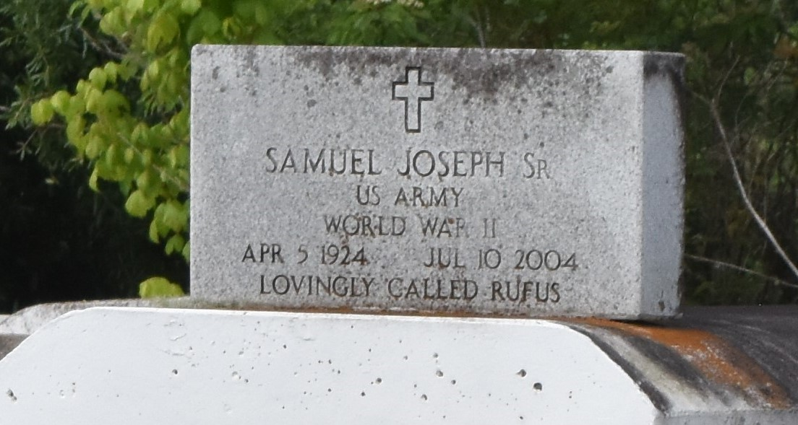

Samuel ""Rufus'' Joseph Sr. departed this earthly life and entered into eternal rest on Saturday, July 10, 2004 at Canon Hospice, Jefferson, LA.
Husband of the late Estella Joseph. Loving father of Melba J. Rousseau, Hilda J. Brochett, Wanda J. Davis, Samuel, Jr., Michael, Mitchell, Spencer and Sidney Joseph and the late Stella Louise Bailey. Also survived by 44 grandchildren, 23 great-grandchildren, other relatives and friends.
Relatives and friends of the family, also pastors, officers and members of Mt. Olive Baptist Church of Paulina, LA and all neighboring churches are invited to attend the funeral services on Saturday, July 17, 2004 at 1:00 p.m. at Mt. Olive Baptist Church, 3143 Hwy 642, Paulina, LA. Rev. Elmo Lee officiating. Interment in Antioch Cemetery of Paulina, LA. Visitation will be at the church from 11:00 a.m. until service time. BARDELL'S MORTUARY of Mt. Airy, LA in charge. Information: 985-535-6837.
The Times-Picayune (New Orleans, LA)
July 16, 2004

