Isadore Kirklin Jr.
November 9, 1932 – October 8, 2009

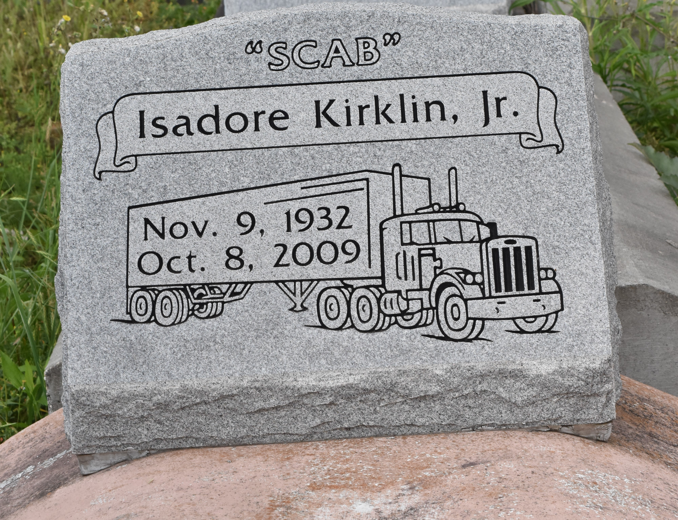

Isadore 'Scab' Kirklin, Jr., departed this earthly life and entered into eternal rest on Thursday, October 8, 2009 at his resident in Paulina, LA.
Son of the late Evelina J. and Isadore Kirklin, Sr. Husband of the late Sarah C. Kirklin by 1st marriage and Audrey J. Kirklin by 2nd marriage. Beloved father of Isadore (Gina M.) Kirklin, III of Prairieville, LA. Grandfather of Dimarcol Lance (Melissa) Kirklin, Sr. of Baton Rouge, LA, Copelon Juan (Zekeidra) Kirklin of Denham Spring, LA, Carlon Jermone Smith of Reserve, LA. Great grandfather of Dimarcol Lance Kirklin, Jr., Shermar Lance Kirklin, Keilon Juan Kirklin, Michael Kirklin, Cade John and Blakelyn Watson. Brother of Ronald Kirklin and Stanley (Cathy) Kirklin of Paulina, LA, Lionel Kirklin of Lutcher, LA, Murphy Kirklin, Sr. and Melvin Kirklin of Oklahoma City, OK, Dorothy Barney and Patricia Ann Long of Paulina, LA, Melba Jean Gaines of Oklahoma City, OK and the late Percy, Oscar and Ethel Mae Kirklin. Also survived by a host of nieces, nephews other relatives and friends. A resident and native of Paulina, LA. Age 76 years.
Relatives and friends, also Pastors, Officers and Members of Greater Evergreen Baptist Church of Paulina, LA and all neighboring churches are invited to attend the Funeral Services on Monday, October 12, 2009 at 11:00 a.m. at Greater Evergreen Baptist Church, 3762 Hwy 44, Paulina, LA. Rev. Nolan Albert, Officiating. Interment in Antioch Cemetery. Visitation will be at the above name church from 9:00 a.m. until service time. Bardell's Mortuary of Mt. Airy, LA in charge. Information: 985-535-6837.
The Times-Picayune (New Orleans, LA)
October 11, 2009

