Isadore Kirklin Sr.
December 25, 1906 – September 23, 2002

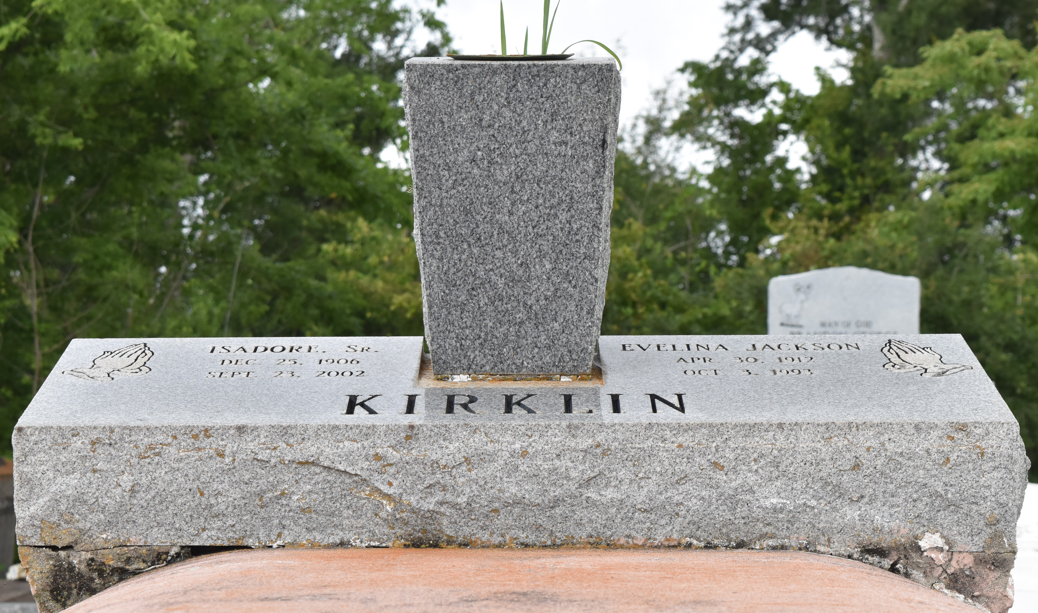
Isadore (The Mustard Greeen) Kirklin, Sr. departed this life on Monday, September 23, 2002.
Son of the late Anthony and Francis Kirklin. Husband of the late Evelina Jackson Kirklin. Father of Isadore Jr., Lionel, Murphy Sr., Melvin, Stanley, and Ronald Kirklin, Dorothy Barney, Jeannie Gaines, and Patricia Long. Father-in-law of Cathy, Audrey, Elaine, and Lucille Kirklin. Also survived by 31 Grandchildren, 40 Great-Grandchildren, and a host of nieces, nephews, other relatives, and friends. Age 96 years.
Relatives and friends of the family, also pastors, officers, and members of Greater Evergreen Baptist Church and all neighboring churches are invited to attend the Wake and Funeral Services on Friday, September 27, 2002 at 8:00 PM and Dismissal Service on Saturday, September 28, 2002 at 11:00 AM at Greater Evergreen Baptist Church, 3762 Highway 44, Reverend Nolan Albert, Pastor, officiating. Visitation Friday evening at the church from 5:00 PM and Saturday morning from 8:00 AM until funeral time. Interment in Antioch Cemetery, Paulina, LA. SERVICES ENTRUSTED TO HOBSON BROWN FUNERAL HOME.
The Times-Picayune (New Orleans, LA)
September 27, 2002

