Murphy Braxton Kirklin Jr.
September 27, 1962 – December 14, 2009

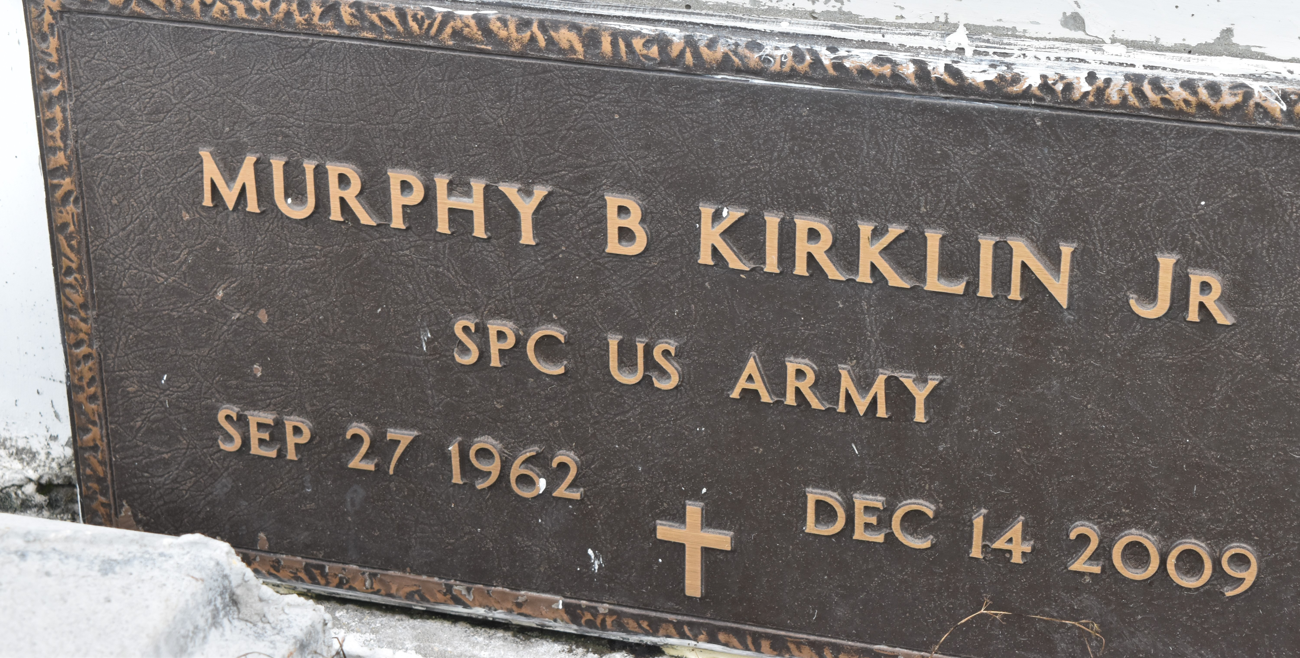

Murphy Braxton Kirklin, Jr. departed this earthly life and entered into eternal rest on Monday, December 14, 2009 at his brother's residence in Vacherie, LA.
Beloved son of Murphy Kirklin, Sr. and the late Gloria Dean Braxton. He was reared by his grandparents the late Isadore Sr. and Evelina J. Kirklin; maternal grandparents were the late Eph and Julia Braxton. Loving father of Murphy III and Anthony Kirklin of Grand Rapids, Michigan. Brother of Leonard (Barbara) Braxton, Debra and Tongia Braxton, Sharlotte (Leo) Diggs, Leah (Myrick) Anderson of Jacksonville, FL and Tunisha Smith of Oklahoma City, OK. Also survived by 1 grandchild and a loyal and devoted companion, Desiree Pittman; a host of aunts, uncles, nieces, nephews, other relatives and friends. Murphy Jr. served his country in the U.S. Army for 12 years. A native and resident of Paulina, LA.
Relatives and friends of the family, also pastors, officers and members of Evergreen Baptist Church of Paulina, LA and all neighboring churches are invited to attend the Funeral Services on Saturday, December 19, 2009 at 11:00 a.m. at the Evergreen Baptist Church, 3762 Hwy. 44, Paulina, LA. Rev. Nolan Albert, officiating. Interment in Antiioch Cemetery, Paulina, LA. Visitation will be at the above named Church from 9:00 a.m. until service time. BARDELL'S MORTURAY of Mt. Airy, LA in charge. Information: (985) 535-6837.
The Times-Picayune (New Orleans, LA)
December 18, 2009

