Ronnie Kirklin
September 27, 1962 – December 14, 2009

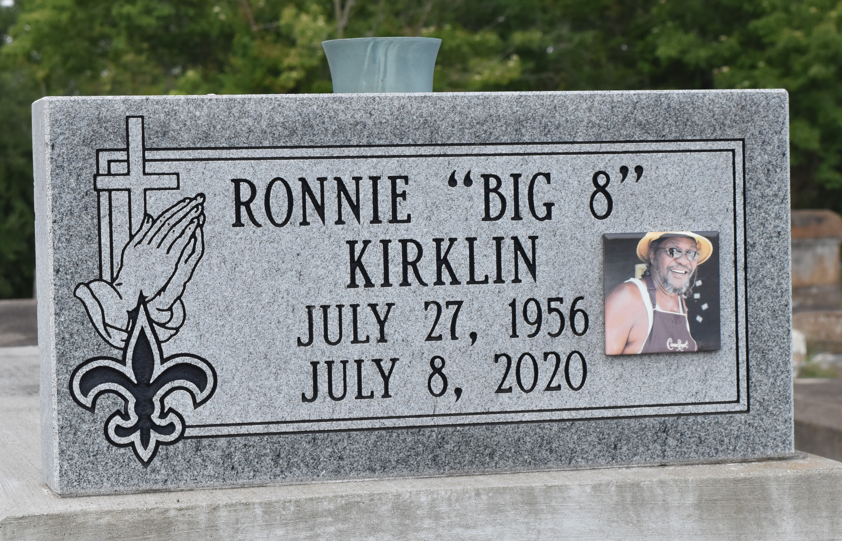

A beautiful bond in the Kirklin family was broken when an angel of the Lord called his beloved child, Ronnie "Big 8" Kirklin home to rest on July 8, 2020 at Our Lady of The Lake Ascension campus, Gonzales, LA. Ronnie was born on July 27, 1956 to the late James Kirklin and Dorothy Russell Kirklin of Paulina, LA. Ronnie was reared in a Christian home. He was baptized when he was only 13 years old on September 21, 1969 at Antioch Baptist Church in Paulina, LA, by the late Rev. Jesse Clay. He was educated in the St. James Parish School System and was a graduate of Lutcher High School, Class of 1976. After high school, Ronnie was employed by Boh Bros. Construction of New Orleans, LA, Peavey Grain Elevator, Paulina, LA, and LaFarge Concrete Company of Gramercy, LA. "Big 8" was a friendly, caring, and straight forward person. He had a special bond with all his nieces and nephews. Although some claim to have been his favorite. He had an infectious smile and loved joking around with family and friends. His favorite hobbies were working on cars, trucks, lawn mowers anything with wheels. He was an AWESOME mechanic. Ronnie (Big 8) and Rodney (Hot Rod) were not only brothers, but the best of friends. They did everything together. During these difficult times, Rodney was his caregiver along with our mother. They NEVER left his side. We all did our part.
Ronnie leaves behind a loving family and many beautiful memories. To cherish these memories are his mother, Dorothy Russell Kirklin, his son, Levar Vallery, his sister Yvonne Kirklin Scott (Alex), his brothers James Kirklin (Elaine), Rodney "Hot Rod" Kirklin, (Katie), Austin Kirklin, (Aariel), Jason Kirklin and Lodric Kirklin, grandchildren Jakoya Jones, Angel Williams, and Levar Williams, devoted friend and former wife, Connie V. Kirklin, godson, Michael Parker, Jr., devoted friends, Roland Arceneaux and Dennis Johnson. A host of aunts, uncles, nieces, nephews other relatives and friends.
Ronnie now joins his dad, James "Buddy" Kirklin, brother, James Kirklin, Jr., maternal grandparents, Ernest and Louvenia Russell, Paternal grandparents James "Bud" and Fannie Kirklin, uncles, Royal, Raymond, Mack Russell, Robert Kirklin, Herman Washington, Sr., Albert Williams, Sr. Robert Ross, Sr. Curly Parker, Felton Dupard, Bernard Keller, aunts Roseanna Dupard, Gloria Russell Keller, Ernestine Williams, Lillian Ross, Clara Parker.
Family, friends, and neighboring churches are invited to attend the viewing of Ronnie "Big 8" Kirklin on Wednesday, July 15, 2020 at Treasures of Life Funeral Services 315 E. Airline Highway, Gramercy, LA 70052 at 11:00am. Visitation will begin at 10:00 am. Interment will follow at Antioch Cemetery Paulina, LA. Final care entrusted to Treasures of Life Funeral Services, 315 E. Airline Highway, Gramercy, LA 70052. To share condolences and thoughts, and to sign guest book, please visit: www.treasurefunerals.com Masks are required!!
Treasures of Life Funeral Services, Gramercy, Louisiana

