Shirley May Kirklin
August 19, 1937 – October 29, 2019

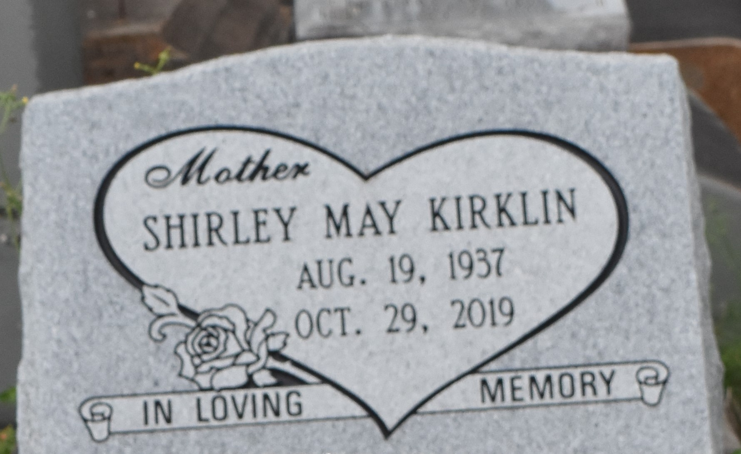

Shirley May Kirklin was peacefully lifted by God's Angels on Tuesday, October 29th, 2019 at the age of 82 at Ochsner Hospital in Kenner, La. She was born in Remy, La to parents Fred and Irene Hayes Kirklin. Shirley was a native of Lutcher, LA for many years, but spent her remaining years at Twin Oaks Nursing Home in Laplace, La.
Shirley was a loving mother and grandmother. To her grandchildren and great-grandchildren she was affectionately known as ""momo"" Shirley. She loved sweets, enjoyed fishing and playing bingo. Her kindness and giving spirit will be deeply missed by her family and friends. She leaves to cherish her precious memories her children, Linda Gaines (late Walter) of Dehnam Springs, La, Elijah Scott Jr. (Lynn) of New Orleans, La, Barbara Manuel (Craig) of Laplace, La, Eldrin Scott (Rose) of Gramercy, La, and Ricky Scott (Audrey) of Baker, La, twenty grandchildren, sixty-five great-grandchildren, and five great-great-grandchildren.
Shirley is preceded in death by her parents Fred and Irene Kirklin, her youngest son, Anthony Scott, her siblings, Rudy Junegain, Phillip Hayes, Delores Lumar and Fred Kirklin.
Relatives and friends of the family, St. John ARC, Old Navy, Fresenius Kidney Care, New Orleans Eye Specialists, Twin Oaks nursing home and all neighboring churches are invited to attend the Homegoing Celebration on Saturday, November 9, 2019 at King Solomon Baptist Church, 2385 N Courseault St, Lutcher, LA 70071 at 10:00 am. Visitation begins at 9:00 am until service time. Interment at Antioch Cemetery in Paulina, La. Final care entrusted to Treasures of Life Funeral Services, 315 E. Airline Highway, Gramercy, La 70052.

The Times-Picayune, New Orleans, Louisiana
Nov. 6 to Nov. 9, 2019

