Detta Lyn (Barconey) Ladd
Unknown – June 26, 2013

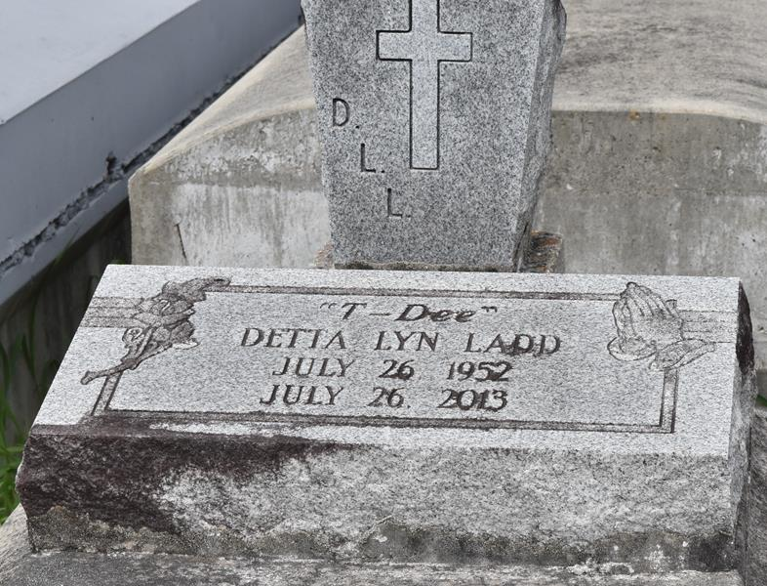

Detta "T-Detta" Barconey-Ladd departed this earthly life on Wednesday, June 26, 2013 at Carrington Place of New Orleans, LA.
Daughter of Illinois Barconey Jr. of New Orleans, LA and the late Bishop Mable Barconey.
She leaves to cherish 5 loving sisters, Melba Smith, Gaynel Johnson, Tongia Anderson, Joyce Barconey, and Joanne Sparks; 4 loving brothers, Warner Olventon (Earline), Lawrence Perry (Pamela), Oliver Sr., and Illinois Barconey III. Niece of Mamie Dell Terry (Earnest). Also survived by a host of nieces, nephews, other relatives, and friends.
Relatives and friends of the family, also pastors, officers, and members of The Greater Evergreen Baptist Church of Paulina, LA., and all neighboring churches are invited to the home going celebration on Saturday, July 6, 2013, at 11:00a.m. at Greater Evergreen Baptist Church, 3399 LA Hwy. 3125, Paulina, LA. Pastor Nolan Albert officiating. Interment in Antioch Cemetery of Paulina, LA. Visitation will be at the above named church from 9:00a.m. until service time. Bardell's Mortuary of Mt. Airy, LA in charge.

The Times-Picayune, New Orleans, Louisiana
July 3-5, 2013

