Huey P. Long Sr.
October 4, 1949 – July 8, 2021

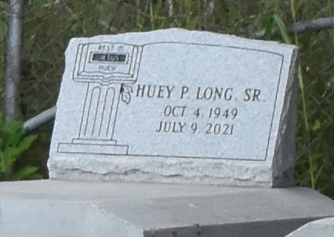

Huey P. Long, Sr., transitioned to eternal life on Thursday, July 8, 2021 at the age of 72 at his residence in Lutcher, LA. He was born to the late Samson Long, Jr. and Rose Mary Wallace Long Jackson. He was the beloved husband of Brenda Prembrook Long and father of Timothy Long (Hollis), Quincy Long (Shernell), April Long, Courtney Long (Zaquita), Kenisha Stemley, Elbridge Colby Johnson and the late Huey P. Long, Jr. He was the proud grandfather of 13 grandchildren and 2 great-grandchildren. He was the brother of Joe Lewis Long, Craig Long, Juliette Williams (Donald Ray), Cheryl Jackson, Dianah Keller, Debra Duperclay, and the late Mayola Cooper, and brother-in-law of Rita Mae Young (Bennie, Sr.). His aunts and uncles include Alton Long, Sr. (Mary), Joseph Long, Sr. (Rose), James Wallace, Rosa Lee Hogan, and Doris Steib (Hamilton).
Relatives and friends are invited to attend a Homegoing Celebration commemorating his life on Saturday, July 17, 2021 at First Community Antioch B.C. 10860 Hwy 3125, Lutcher, LA 70071, at 11:00 am. Visitation will begin at 9:00 am until the service time. All visitors are asked to wear a mask. Rev. Eric Keller officiating. Interment at the old Antioch Cemetery, Antioch Ln. Paulina, LA. Viewing will be held Friday, July 12, 2021 from 4 p.m. until 7 p.m. at Bardell's Mortuary, 3856 LA-44, Mt. Airy, LA 70076. Services entrusted to Bardell's Mortuary. Information: (985) 535-6837.
The Advocate, Baton Rouge, Louisiana
Jul. 15 to Jul. 17, 2021

