Albertha J. Marcell
June 23, 1947 – November 11, 2014

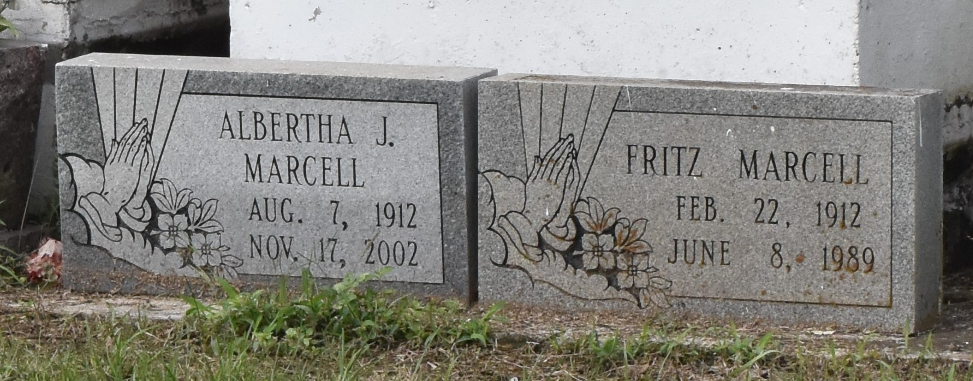

Alberta Marcell, Sunday, November 17, 2002, at 3:15 PM. Age 90 years and a native of Welham, Louisiana and a resident of Paulina, Louisiana. Mother of Margaret Russell, Alice Marcell, both of Paulina, LA. Also survived by 17 grandchildren and 26 great-grand children.
Funeral Services will be held on Saturday, November 23, 2002 at 11:00 AM at Evergreen Baptist Church, Paulina, LA. Visitation at Evergreen Baptist Church on Saturday, November 23, 2002 from 9:00-11:00 AM. Interment Antioch Cemetery, Paulina, LA.

The Times-Picayune, New Orleans, Louisiana
November 22, 2002

