Dwayne Andre Marcell
December 14, 1963 – September 19, 2019

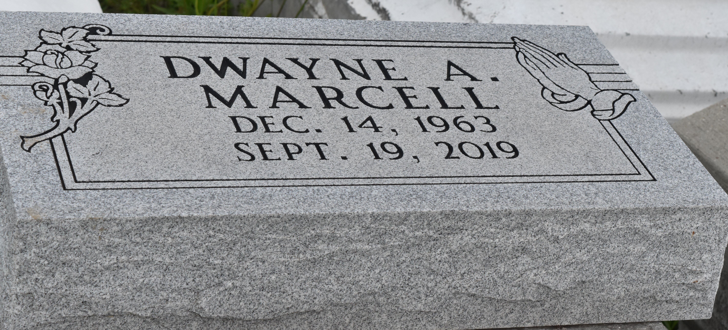

Dwayne Andre Marcell, 55 a native of Paulina and a resident to Vacherie passed away Thursday September 19, 2019 at St James Parish hospital.
Dwayne is survived by and leaves to cherish his memories, one sister(Sonja Marcell), one sister-in-law (Jennifer Marcell), fiance (Darlene Mayo), one aunt (Alice Marcell) and a host of nieces, nephews, relatives and friends.
Dwayne is preceded in death by his parents (Georgia Mae Marcell and Freeman Marcell Sr.), two brothers (Freeman Marcell Jr. and Micheal Marcell), one sister (Fayona Brown) and both paternal and maternal grandparents.
The family wishes to express their sincere gratitude for the overwhelming amount of love shown to them during their moment of bereavement. No act of kindness has gone unnoticed, and a more formal thank you will be done at a later date.
Please continue to keep this family in your thoughts and prayers.

Lawson - Rollins Purple Shield Funeral Home, Gonzales, Louisiana

