Deborah W. Martin
December 25, 1955 – May 4, 2016

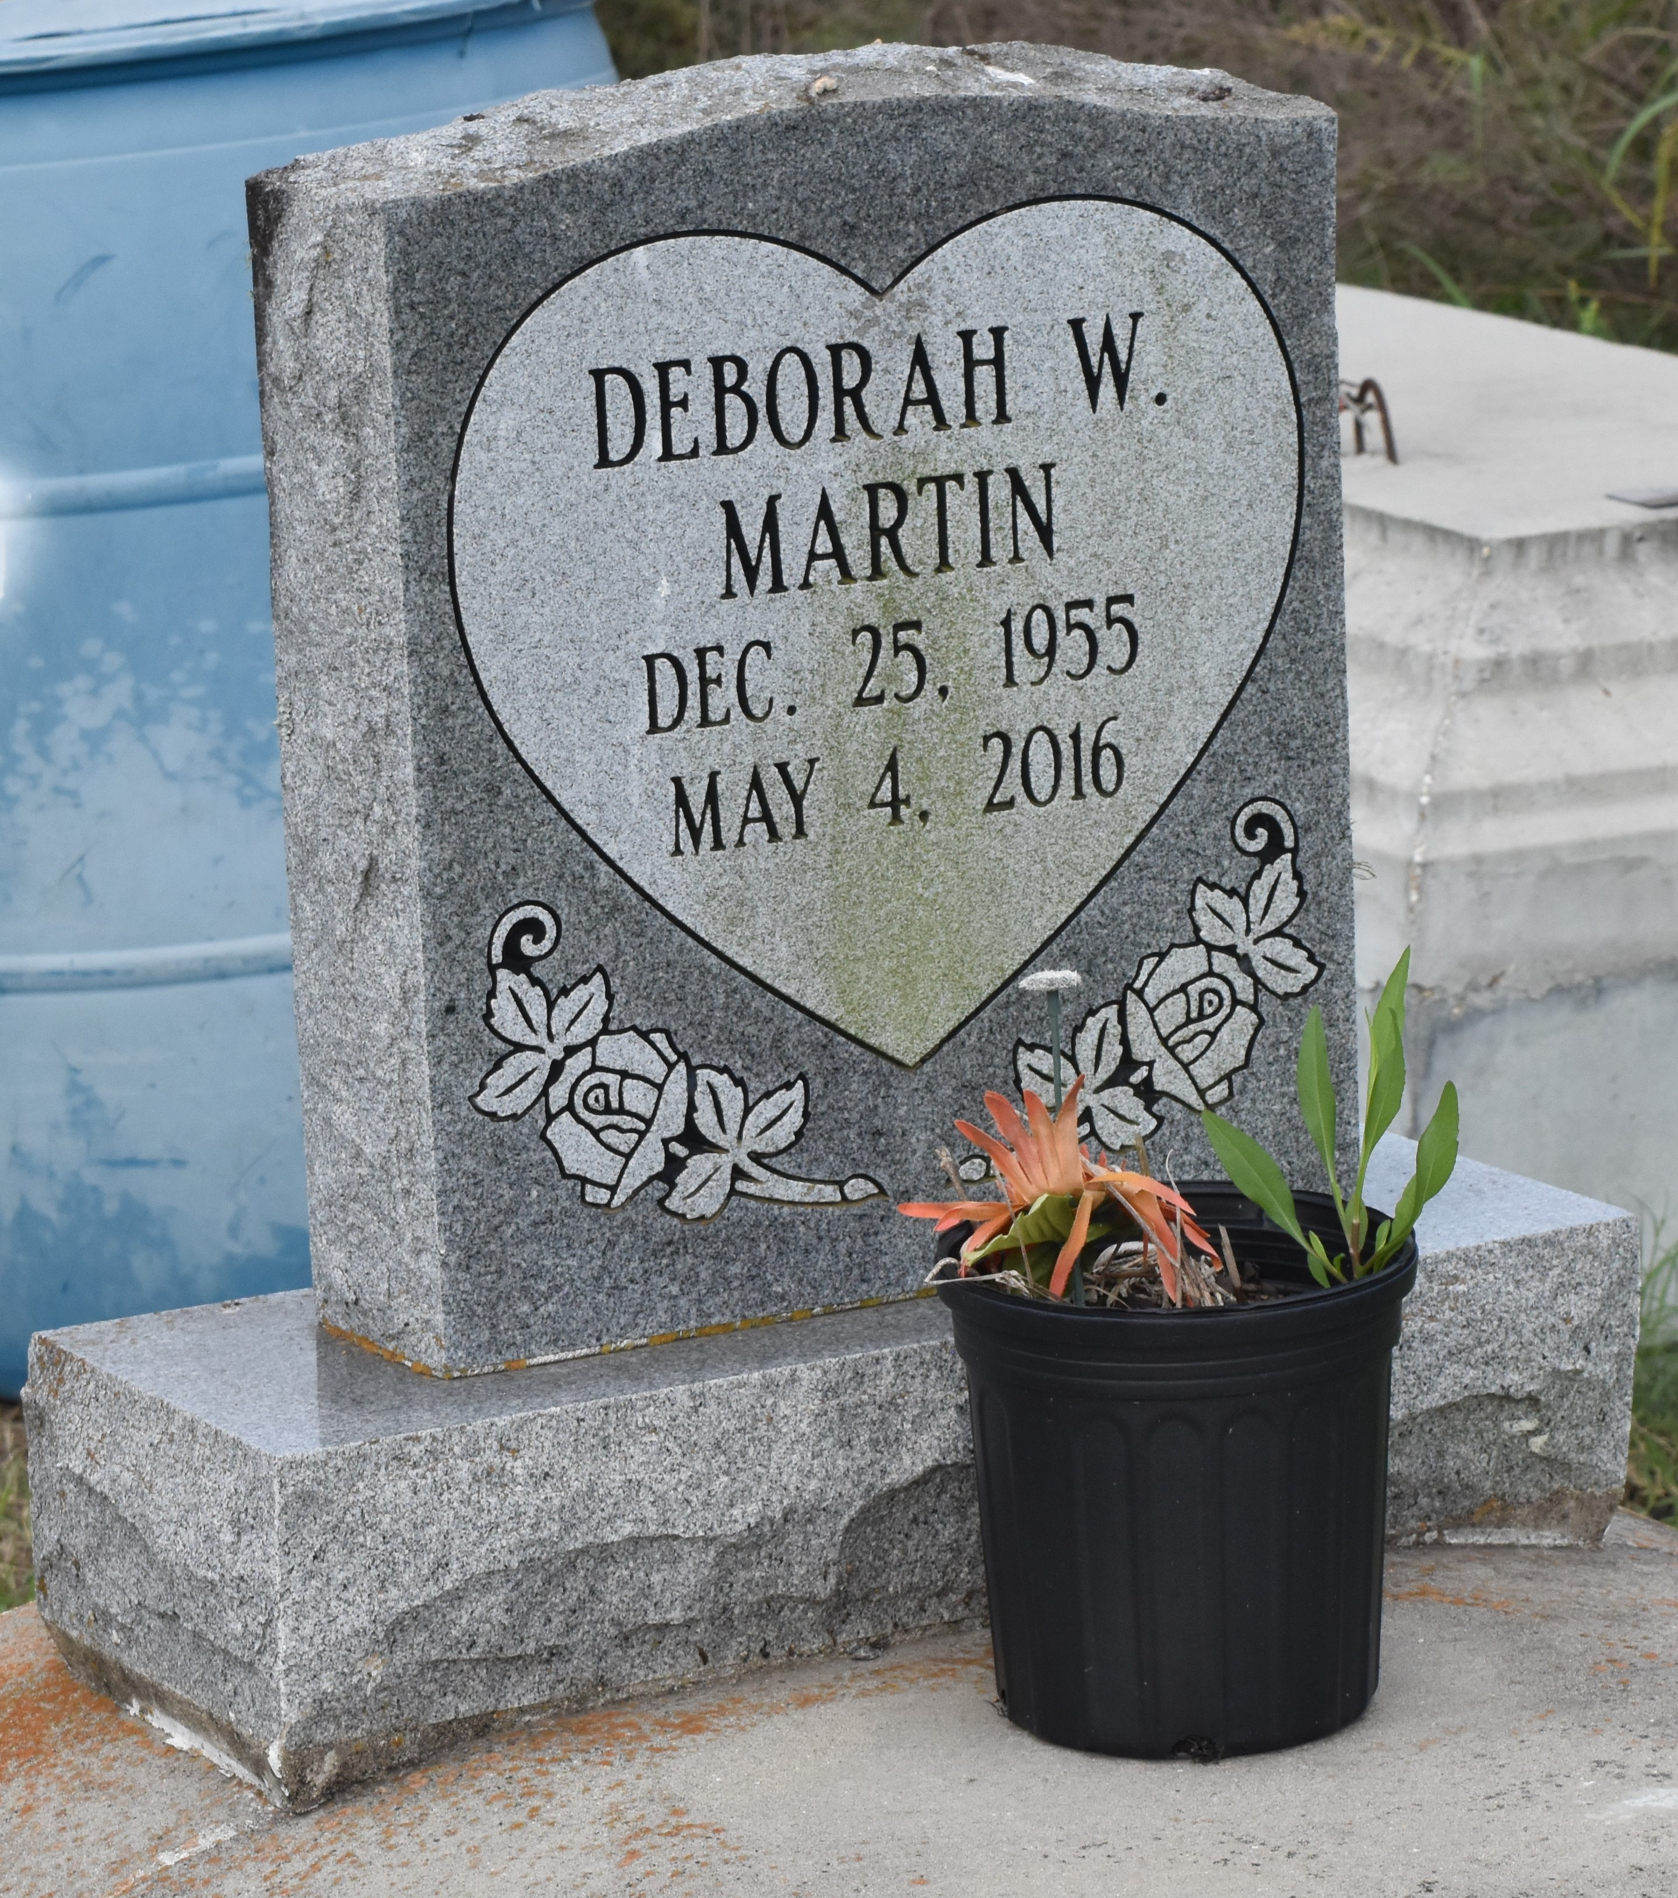

Deborah A. Martin departed this life on May 4, 2016. She is survived by her husband: Johnny Martin Jr., mother: Emeline K. Washington, daughter: Nekedra Davenport, step-daughters: Jamekco Lewis, Kursten Munson, Valerie Wilson, Jonda and Janay Martin, (6) grandchildren, (1) sister, (4) brothers, and a host of other relatives and friends. A native of Paulina, LA. Age 60.
Funeral services will be held at First Community Antioch B.C., 10860 LA HWY 44, Gramercy, LA 70052, on Saturday May 14, 2016 at 11:00am, Rev. Ferdinand Gaines, Pastor, Pastor Herman Clayton, officiating. Visitation 9:00am until service time. Internment at Antioch cemetery, Paulina, LA. Service Entrusted to Hobson Brown Funeral Home, Garyville, La 70051, (985) 535-2516.
The Advocate, Baton Rouge, Louisiana
May 12 to May 14, 2016

