Della (Joseph) Martin
August 21, 1913 – February 8, 2002

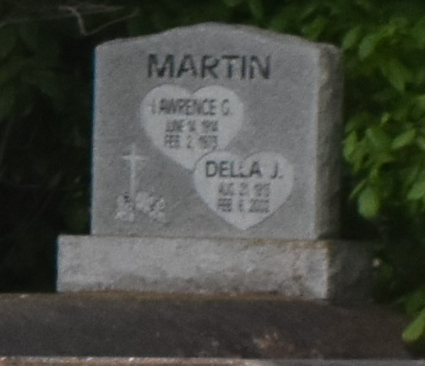

PAULINA - Della Joseph Martin, 88, a native of Mt. Airy and resident of Lutcher, died Feb. 8. She was the wife of the late Lawrence Martin Sr., mother of Margie Young, Doris Bowser, Donna Barker and Adeline, Jeanette, Joyce, Larry, Tyrone, Warren, George and the late Lawrence Martin Jr. and stepmother of Brenda Scott and Calvin Hayes.
She was the daughter of the late Celestin and Adeline Clement Joseph and sister of the late Enola Stewart and Henry Sr., Celestin Sr., Charlie, Freddie and Aristede Joseph.
She was also survived by 37 grandchildren, 76 great-grandchildren and five great-great-grandchildren.
Services were Feb. 18 at King Triumph Baptist Church, Lutcher, with interment at Antioch Cemetery, Paulina.

L'Observateur (La Place, LA)
Saturday, February 23, 2002

