Grayland Edward Martin Sr.
June 22, 1982 – April 7, 2020

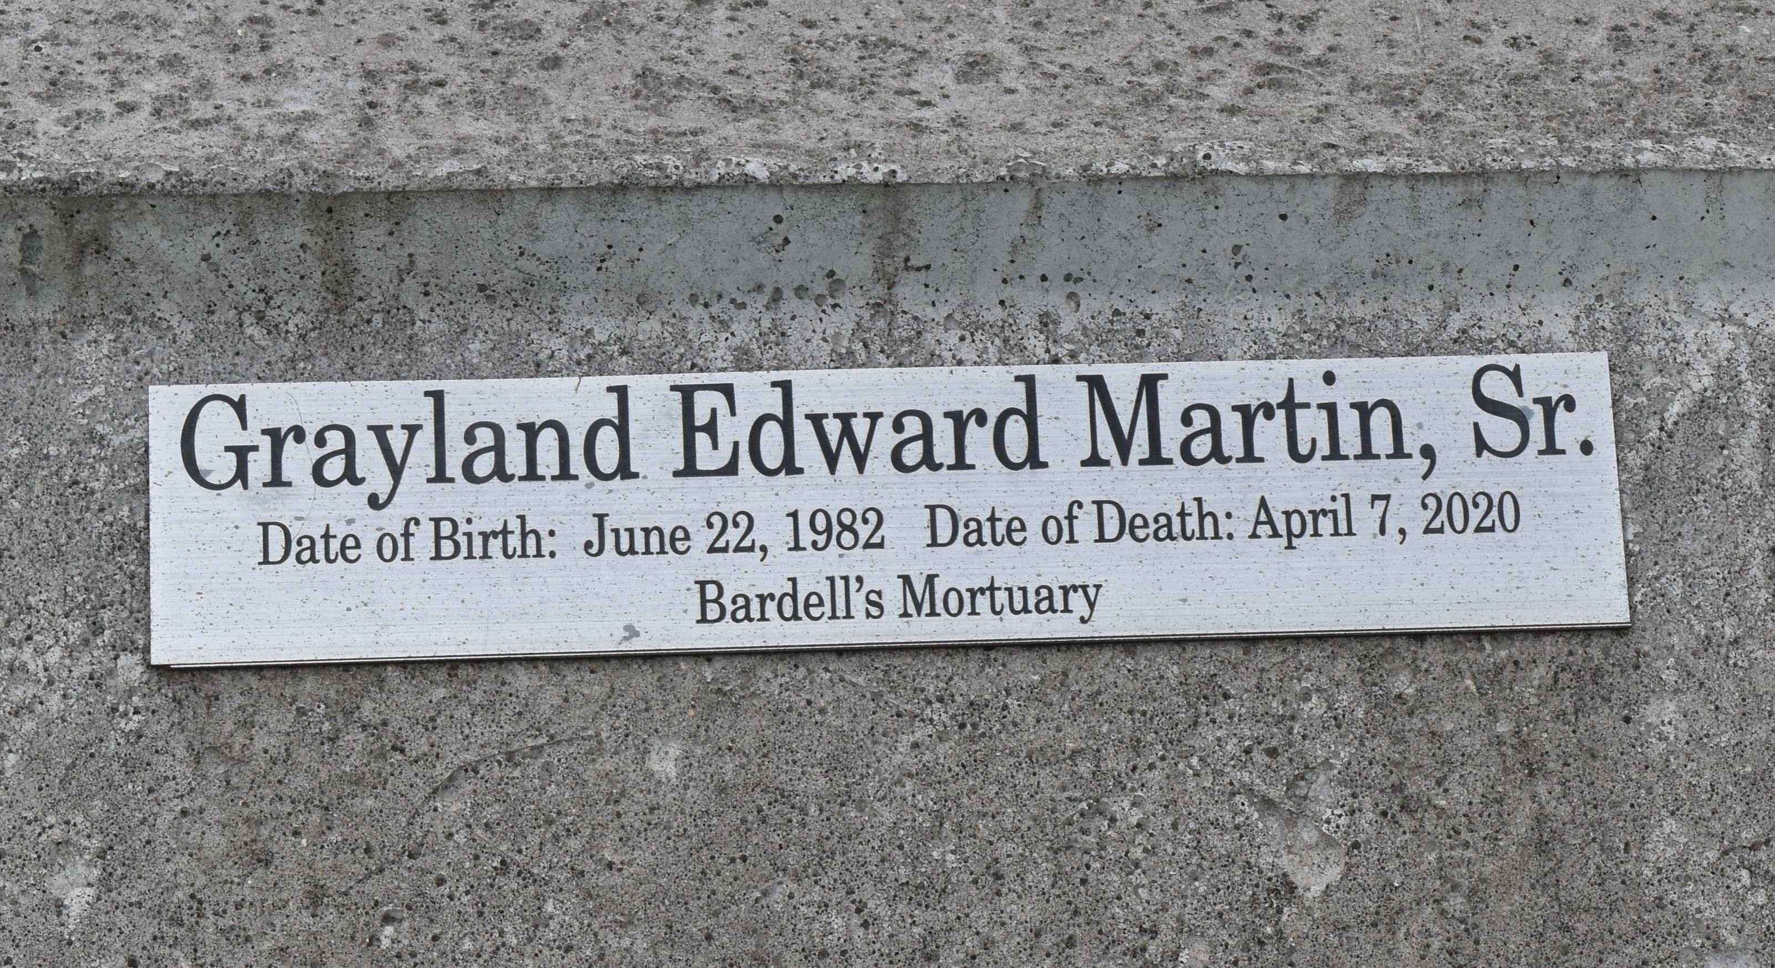

Grayland "Meat" Edward Martin, Sr., at the age of 37 years, departed this earthly life and entered into eternal rest on Tuesday, April 7, 2020 at his residence in LaPlace, LA.
Son of the late Alton Bovie and Melba Martin. Beloved husband of Sloan Johnson-Martin. Loving father of Grayland Martin Jr., Skyla D. Martin, and Siyah D. Martin. Brother of Wayland Martin, Seraphiane Martin, Alton (Myra) Bovie Jr., Clyde (Katrina) Bovie, and Allyson Bovie Mitchell. Son-in-law of Herbert and Deon Johnson. Brother-in-law of Herbert Johnson Jr. and Carla (Everett) Armand. Also survived by a host of aunts, uncles, nieces, nephews, other relatives, and friends.
Grayland was preceded in death by his parents, Alton Bovie Sr. and Melba Martin; sisters, Charolette Martin and Catherine Bovie.
Due to the current health crisis, the viewing will be Friday, April 17, 2020 from 3:00 p.m. until 5:00 p.m. at Bardell's Funeral Home, 3856 Hwy 44 Mt. Airy, LA 70076. Burial will be private. Bardell's Mortuary of Mt. Airy, LA in charge. Information: (985) 535-6837.

The Times-Picayune, New Orleans, Louisiana
Apr. 15 to Apr. 16, 2020

