Joyce Ann Martin
May 1, 1946 – May 1, 2012

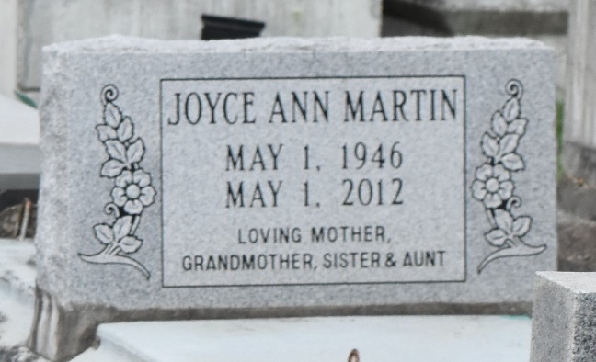

Joyce Ann Martin, 66, departed this earthly life May 1, 2012. She was born in Mt. Airy on May 1, 1946, and resided in Los Angeles for the past 40 years.
She was preceded in death by her parents, Lawrence Sr. and Della Martin, and brother Lawrence Jr.
She was the beloved mother of Kanacio D. Martin Sr. (Tomika) and Kimeyon Washington, grandmother of Kanacio D. Martin Jr., Skylar Courtney Holmes, Kendall Smith, Hudson Martin and Brookelyn Martin. She leaves to cherish her precious moments nine brothers and sisters, Betty, Warren (Pat), Margie, Jeanette, Adalene, Doris (Morris), George Allen (Carol), Larry (Evangeline), Donna (Robert), Tyrone (Glenette), Aunt Willie Mae Burns, Uncle Morris Martin and a host of nieces, nephews, family and friends.
Services were entrusted to Solomon Mortuary Inc. 10625 S. Broadway, Los Angeles, CA 90003, (323) 757-1754. A home going celebration was held at Greater New Zion Missionary Baptist Church in Los Angeles on Tuesday, May 8, 2012. Burial will be held at Antioch Cemetery in Paulina on Saturday, May 12, 2012.

L'Observateur (La Place, LA)
Wednesday, May 9, 2012

