Larry L. Martin
June 23, 1953 – September 1, 2015

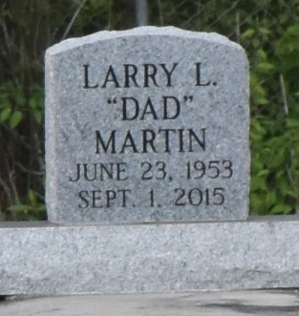

A native of Paulina and a resident of Gramercy, he passed away at his family home in Lutcher, at 12:25 P.M., Tuesday, September 1, 2015. He was 53.
Visiting at Greater King Triumph Baptist Church, Lionel Washington Street, Lutcher, Saturday, September 12, 2015 from 9:30 A.M. until religious services at 11:00 a.m., conducted by the Rev. Charles Jones. Viewing will be before the services ONLY. Interment in Antioch Baptist Church Cemetery, Paulina.
Survived by his wife, Evangeline Jackson Martin. A daughter, Lacria Martin (Jeff) Williams. Two sons: Lowell and Jewell Jackson. Sisters: Doris (Morris, Jr.) Bowser, Jeanette Martin, Margie M. Young, Brenda Scott and Donna Barker. Brothers: Warren (Serena) Martin, George Martin, Tyrone (Glynette) Martin and Calvin Hayes. Sisters in law: Martha Ellis Breaux and Terimal (Joseph, Jr.) Long, and Norma Martin. Brothers in law: Kenneth (Karen) Jackson and Troy (Diedra) Jackson. Daughter in Law: Jeanne Johnson and Karmarie Perez'Arce. An uncle, Morris Martin, Sr. and an aunt, Willie Mae Burns. Seven grandchildren, numerous nieces, nephews, cousins, other relatives and friends.
Preceded in death by his parents: George Martin, Sr. and Della Joseph Martin. Two sisters: Adelene Martin and Joyce Ann Martin. A brother, Lawrence Martin, Jr. Brothers in law: Robert Barker and Clarence Breaux.
Brazier-Watson Funeral Home in charge of arrangements. Visit us at www.brazierwatson.com to sign our guest book and send words of comfort to the family.

The Advocate, Baton Rouge, Louisiana
Sep. 10 to Sep. 12, 2015

