Ricky A. Martin
October 2, 1950 – August 17, 2008

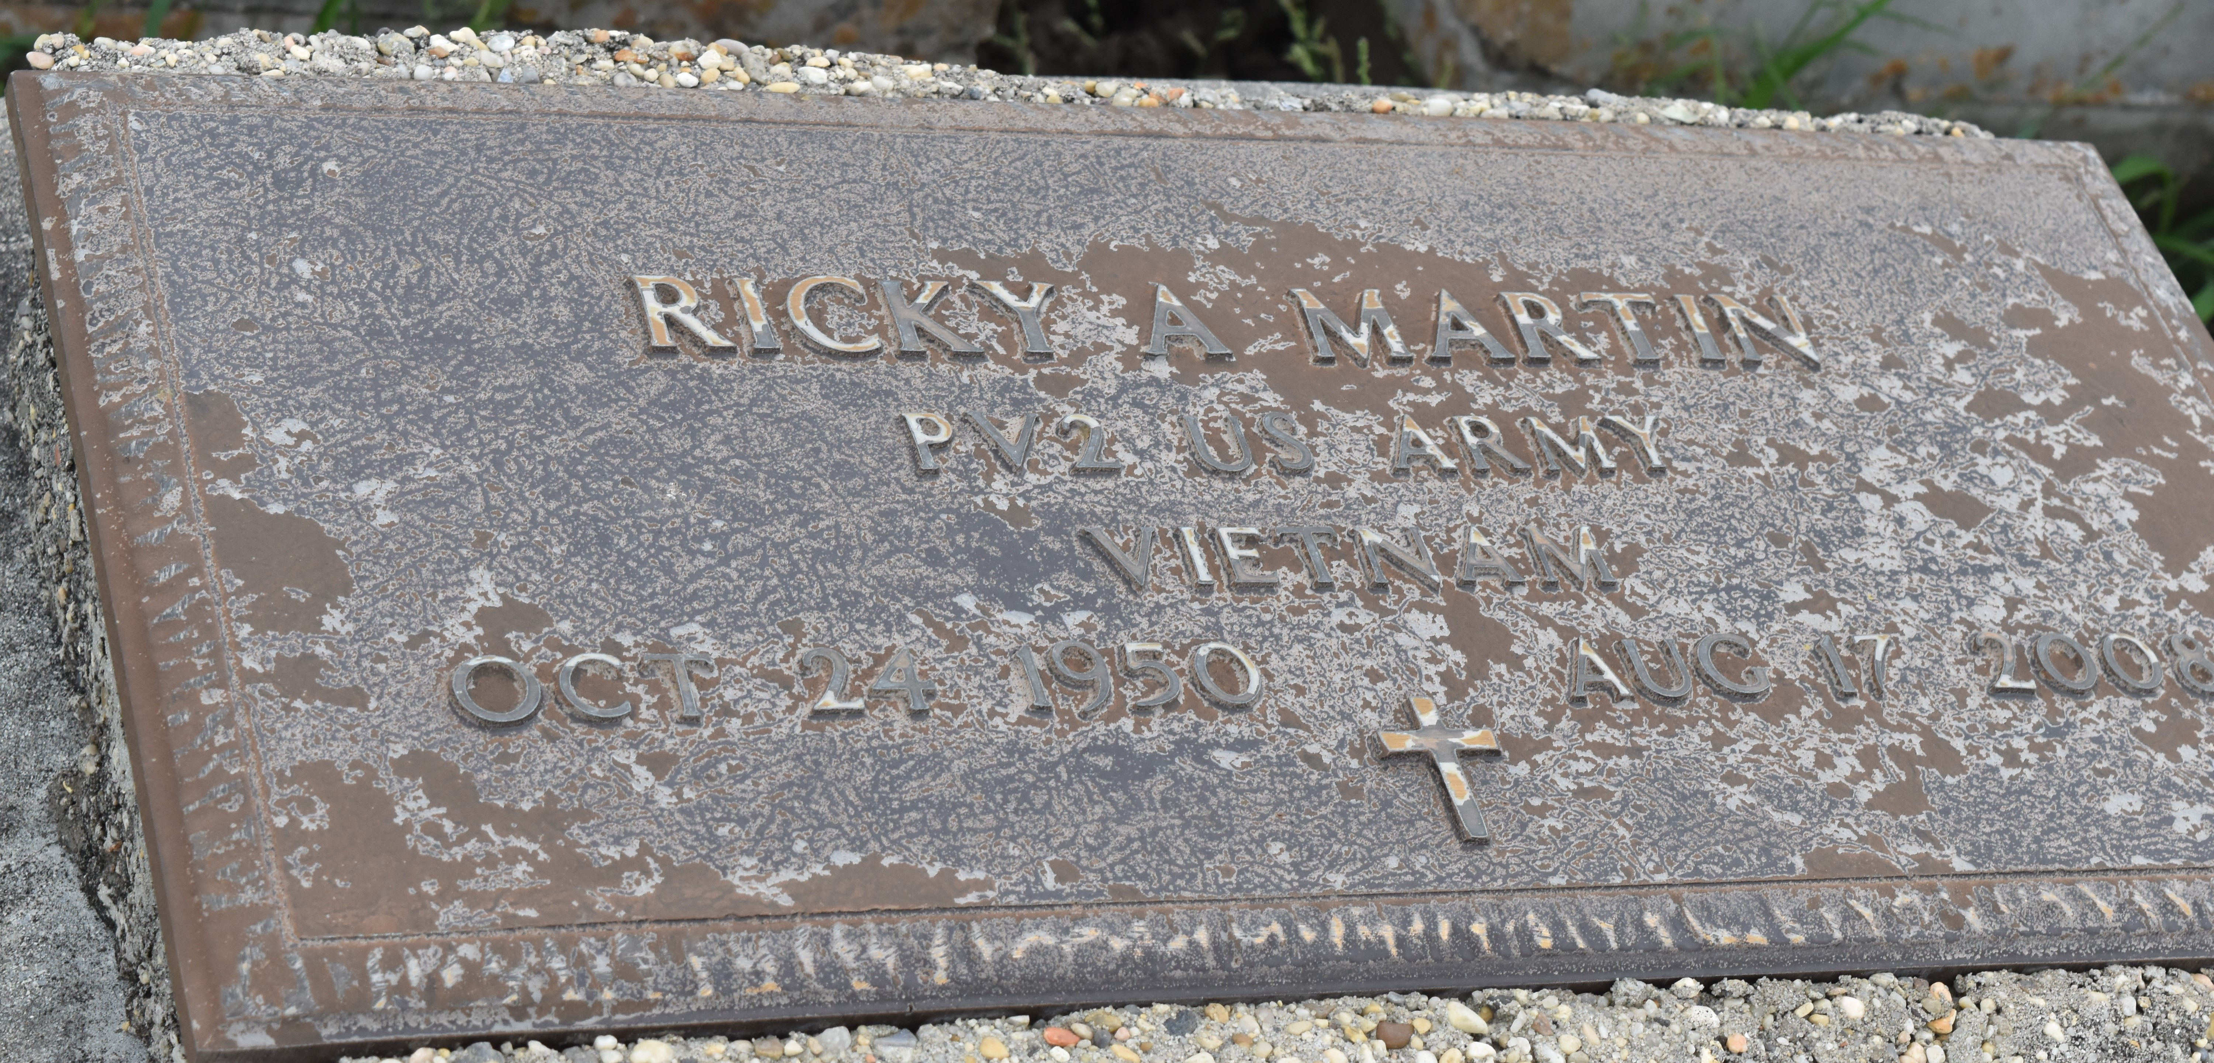

Ricky A. Martin, age 57, a United States Veteran, departed this life on Sunday, August 17, 2008 in Metairie, LA. Son of the late Clarence and Dorothy Martin. Loving companion of Laverne Green. Father of Brittany Martin, Nicole Age, Ernest III, Eric and Anthony Green. Brother of Larry, Wayne and Mary Ann Martin and Maxine Bovie. Also survived by 14 grandchildren, 1 great-grandson, a host of aunts, uncles, nieces, nephews, cousins and friends. A native of and resident of Reserve, LA.
Pastors, officers and members of Milesville Memorial Church of God in Christ and all neighboring churches are invited to attend the Funeral Service on Friday, August 22, 2008 at 11:00 a.m. at the above named Church, 129 Apple St., LaPlace, LA. Bishop Ronald Frank, Pastor, officiating. Interment in Antioch Cemetery, Paulina, LA. Viewing at the Church on Thursday from 5:30 until 7:00 p.m. and on Friday from 8:00 a.m. until service time (ONLY). Services entrusted to HOBSON BROWN FUNERAL HOME Garyville, LA (985) 535-2516.

The Times-Picayune, New Orleans, Louisiana
August 21, 2008

