Audrey Mae (Collins) McField
August 25, 1933 – July 23, 2011

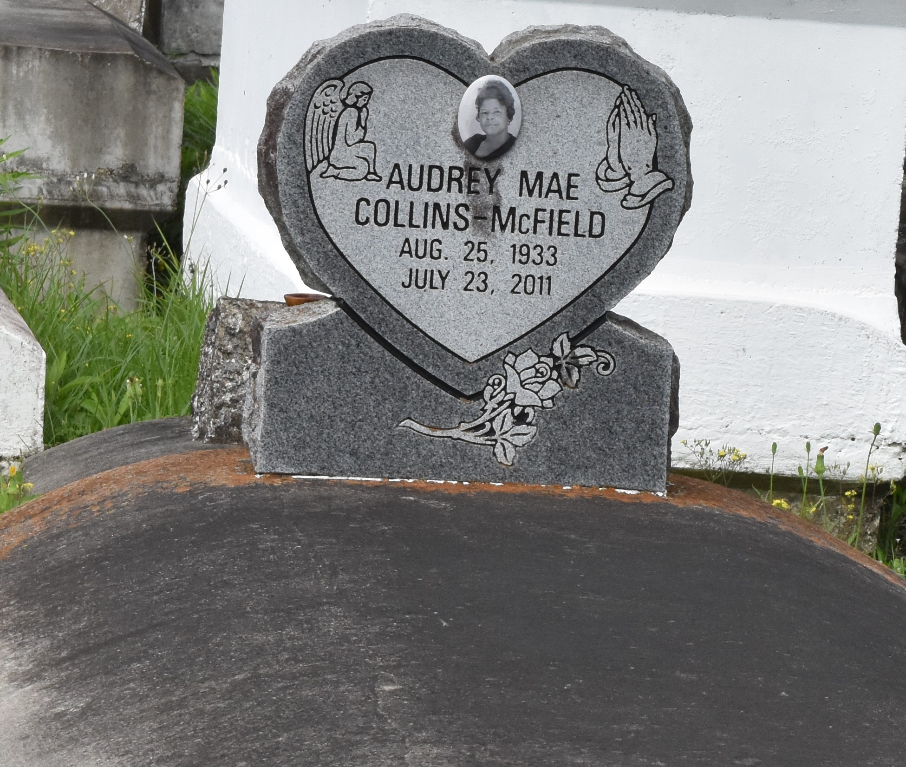

Oudra "Audrey" Mae Collins McField, age 77, departed this life on Saturday, July 23, 2011 in Gramercy, La. Daughter of the late Leroy and Ethel Collins. Wife of Ernest McField. Mother of Georgia Mae Honorae. Sister of Vera C. Smith, Mary Ann Collins and Terrell Collins. Also survived by 3 grandchildren, 1 uncle, 1 aunt, sisters-in-law, brothers-in-law, 1 godchild, and a host of nieces, nephews and cousin.
Service will be held at the First Community Antioch Baptist Church, 10860 Hwy. 3125, Lutcher, LA on Saturday, July 30, 2011 at 10:00 a.m. Interment in Church Cemetery. Visitation will begin at 9:00 a.m. Rev. Ferdinand Gaines Sr., Pastor, Officiating. Services Entrusted to Hobson Brown Funeral Home Garyville, La 70051 (985) 535-2516.

The Times-Picayune, New Orleans, Louisiana
July 29, 2011

