Gerard Timothy Michael Sr.
March 21, 1984 – September 5, 2022

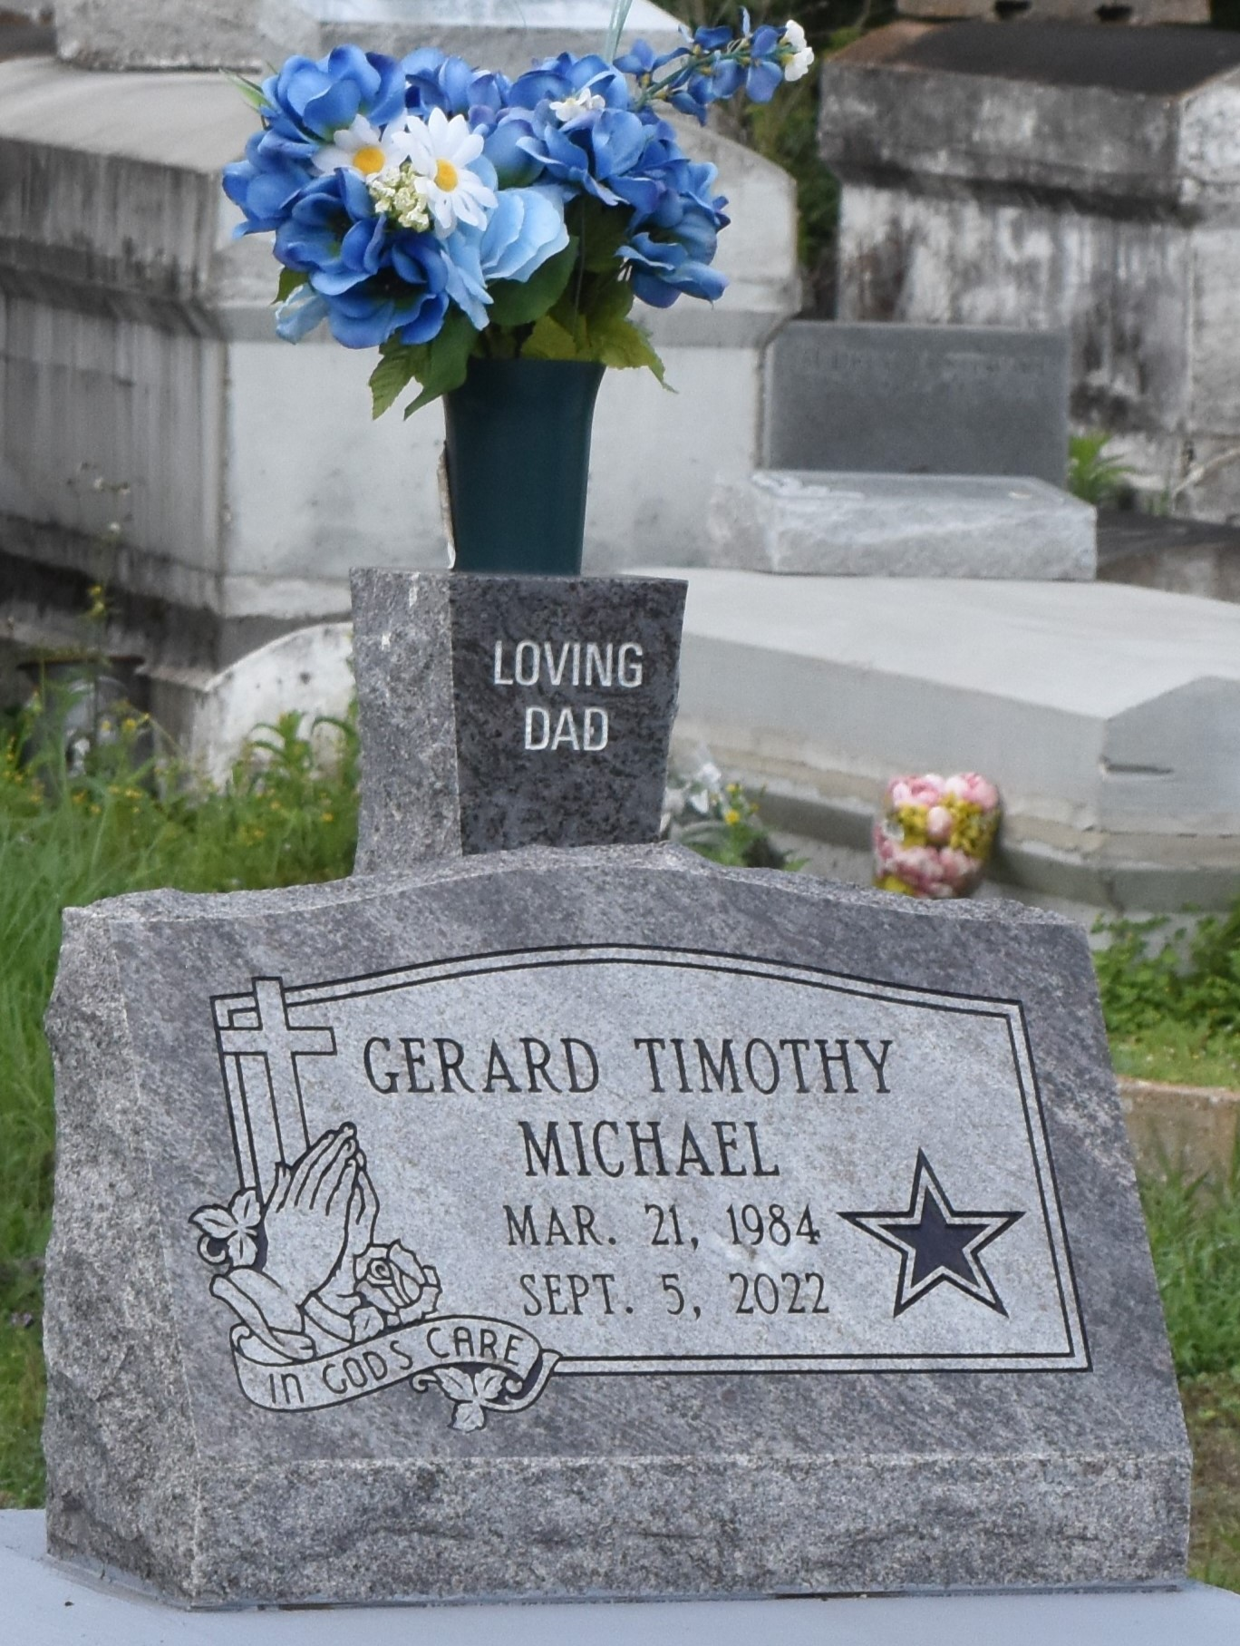

Gerard Timothy Michael Sr. was born March 21, 1984, to the parentage of Donel Faye Gray and the late Gerard Mitchell in New Orleans, LA. Gerard departed from this earthly life on September 5, 2022, at his residence which he shared with his companion Olivia Washington. He heard the voice of Our Father saying, "Come unto me all ye that labour and heavy laden, and I will give you rest.” Gerard was baptized at an early age by the Rev. Versey Fluence at the Greater King Triumph Baptist Church of Lutcher LA. Gerard was educated in the public school system where he completed his studies from Lutcher High School in 2003.
Gerard leaves to cherish his memories: his three children, Ajahne Cooper, Gerard Timothy Michael Jr., and Skye Michael; his loving mother, Donel Faye Gray; maternal brother, Joseph Gray (Jessica); and paternal sisters, Tiffany Martin, Queena Gant, and Deana Mealy. He was loved by many so he also has great memories of his nieces and nephews, aunts and uncles, a host of cousins, devoted friends, and other relatives. He was preceded in death by his father, Gerard Mitchell and his aunt, Sarah Albert whom he cared for deeply.
Family and friends are invited to the homegoing celebration on Saturday, September 17, 2022, at 10 am at Greater Golden Grove Baptist Church, 127 S. Mulberry Ave., Gramercy, LA 70052. Visitation will be held from 8 am until service time. Viewing will be held Friday, September 16, 2022, from 3 pm to 6 pm at Bardell's Mortuary, 3856 LA 44, Mt. Airy, LA 70076. Masks and social distancing will be enforced. Services entrusted to Bardell's Mortuary. Information: (985) 535-6837.
The Advocate, Baton Rouge, Louisiana
September 16, 2022

