Shirley M. (Duhone) Milton
November 15, 1959 – November 16, 2006

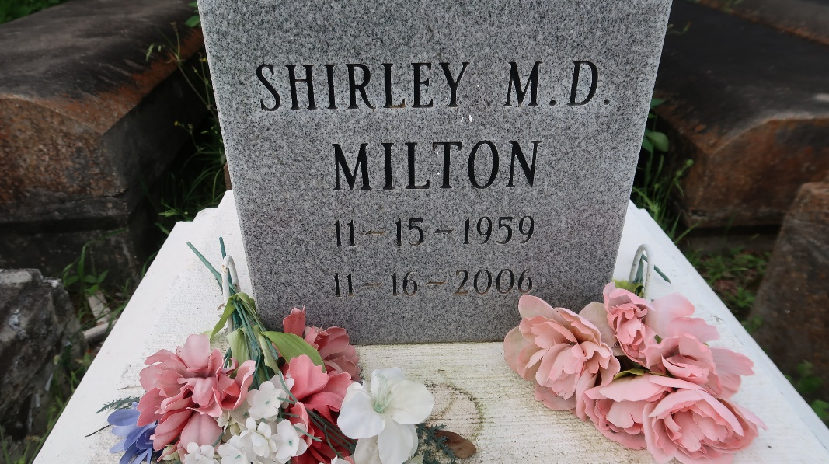

Shirley Duhone Milton at St. James Parish Hospital, Lutcher, La. on Thursday, November 16, 2006 at 10:40 p.m. Daughter of Audrey Beckett Duhon and the late Joseph Duhon, Sr. Wife of Bobbie Milton. Mother of Kesha (Donald) Russell, Tina, Angela, Shelita, Nancy, Ann, Dan and Steven Duhone and the late Yolanda Duhone. Sister of Diane (Frank) Ware, Cynthia (Lawrence) Williams, Grace (Severa) Joseph, Joseph Duhone, Jr. and the late Nicole Kirklin. Brother-in-law of Kevin Kirklin. Also survived by 12 grandchildren, numerous nieces, nephews, cousins, other relatives and friends, including Anthony Nelson. Age 47.

Visiting at Israelite B.C., Lutcher, La. Wednesday, November 22, 2006 from 9:30 a.m. until religious services at 11:00 a.m. Conducted by the Rev. Kevin Fredricks. Interment in Antioch Cemetery, Paulina, La. Brazier-Watson Funeral Home in charge of arrangements.

The Times-Picayune, New Orleans, Louisiana
Nov. 21, 2006

