Evera Mitchell Sr.
March 17, 1940 – July 19, 2021

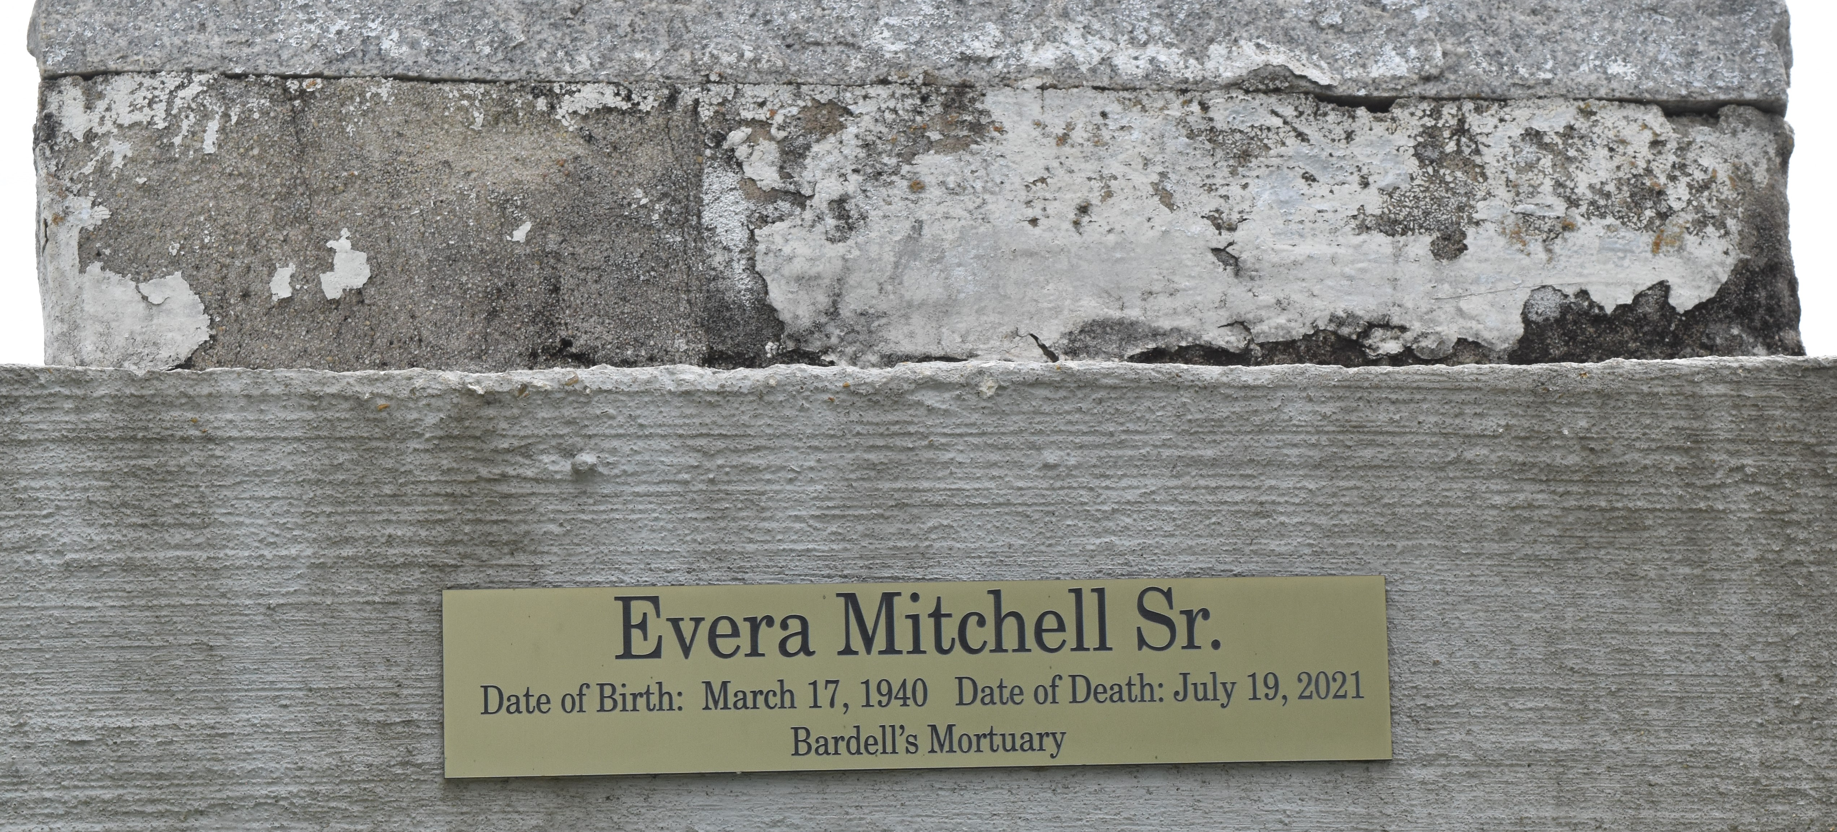

Evera Mitchell, Sr. departed this life and entered eternal rest at St. James Parish Hospital in Lutcher, LA at 10:36 p.m. on Monday, July 19, 2021. Beloved husband of Hattie Hayden Mitchell. He was 81.
He leaves to cherish his memories, his devoted wife, Hattie Hayden Mitchell; daughter, Kimberly Mitchell; sons, Evera Mitchell, Jr. and Dewayne (Leah) Mitchell; sister, Jeanette Geurin; brothers, Anthony (Janice) Boudreaux, Joseph Boudreaux, Raymond Mitchell, and Leroy (Josephine) Bourgeois; sisters-in-law, Marion Edwards and Emily Jackson; brothers-in-law, Raymond (Rosemary) Hayden, Sr., and Larry Hayden, Sr., four grandchildren, 3 great-grandchildren, and a host of nieces, nephews, cousins, other relatives, and friends.
Evera was preceded in death by his mother, Clara Mitchell; sister, Idola Robertson; brothers, Richard, Royal, and Mark Mitchell; sisters-in-law, Wilberine Rucker and Elnora Parker; and brothers-in-law, Rogeis Hayden, Sr. and Spencer Hayden, Jr.
Family and friends are invited to the Homegoing Celebration on Saturday, July 24, 2021 at 11 a.m. at First Community Antioch B.C., Hwy 3125, Lutcher, LA. Viewing will be held from 9:30 a.m. until service time. Interment in Antioch B.C. Cemetery in Paulina, LA. Visitation will be held Friday, July 23, 2021 from 3 p.m. until 6 p.m. at Bardell's Mortuary, 3856 LA-44, Mt. Airy, LA 70076. Services entrusted to Bardell's Mortuary. Information: (985) 535-6837.
The Advocate, Baton Rouge, Louisiana
July 22 to July 24, 2021

