Mark Lee Mitchell
April 3, 1956 – May 23, 2006

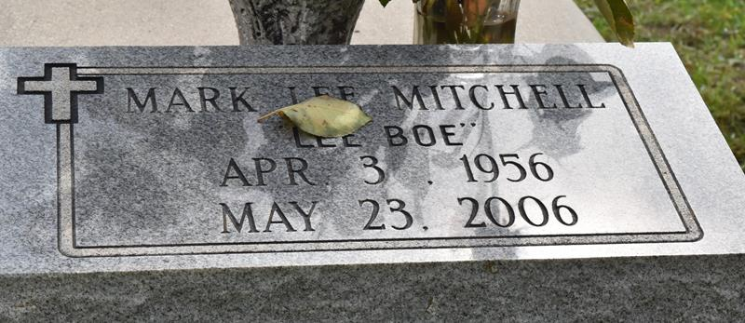

A native and resident of Paulina, he died at 6:15 p.m. Tuesday, May 23, 2006, at his home.
He was 50. Visiting at First Community Antioch Baptist Church, La. 3125, Lutcher, on Saturday, May 27, from 9:30 a.m. until religious service at 11 a.m., conducted by the Rev. Ferdinand Gaines Jr. Burial in the church cemetery.
He is survived by two daughters, Renika and Martine Stemley; son, Teric and spouse LaDaisha Wilson; stepson, Elliott Bolden; two sisters, Idola Robertson and Jeanette and spouse Anthony Guerin; five brothers, Evera and spouse Hattie, Richard and spouse Brenda, and Raymond Mitchell, and Joseph and Anthony Sr. and spouse Janice Boudreaux; his companion, Lynette Mitchell; stepsisters, Lula Griffin, Louise and spouse C.J. Clark, Dotsie Jackson, Valery and spouse Wayne Batiste; stepbrothers, Rudolph and spouse Mable Schofield, Lawrence, Ronald and spouse Melanie, Leslie and spouse Doloris, and Wesley Boudreaux Jr.; aunt, Julia Mitchell; uncle, Lucien B. Mitchell; four grandchildren, nieces, nephews, cousins, other relatives and friends.
He was preceded in death by his parents, Clara Mitchell and Wesley Boudreaux Sr.; and two brothers, Royal and Heary Mitchell.
Brazier-Watson Funeral Home is in charge of arrangements.

The Advocate, Baton Rouge, Louisiana
May 26, 2006

