Royal Mitchell
June 28, 1957 – November 20, 2002

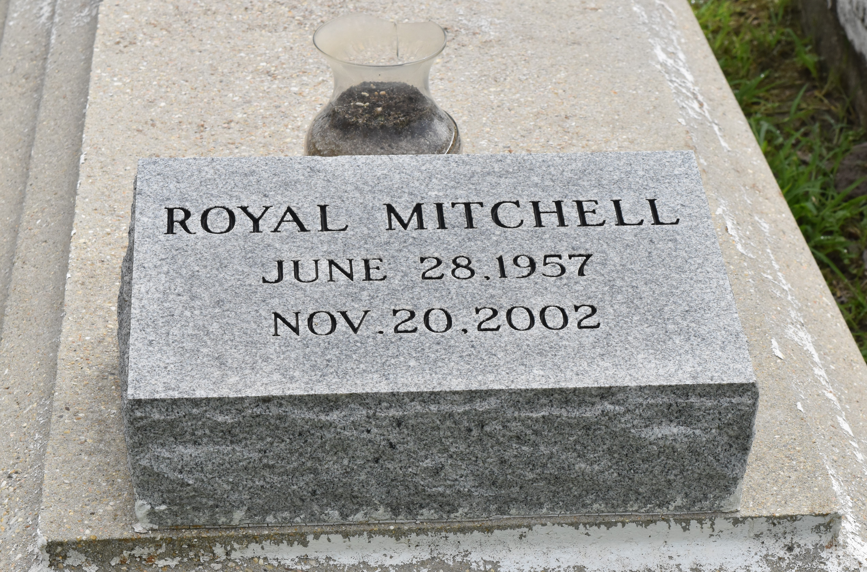

Royal (Uncle Coon) Mitchell at his residence, New Orleans, La., at 8:50 P.M., Wednesday, November 20, 2002. Son of the late Clara Mitchell. Father of Sada Martin of New Orleans, La. Brother and brother-in-law of Idola and Ernest Robertson, Jeannette and Anthony Guerin, Evera and Hattie, Richard and Brenda, Mark and Lynette and Raymond Mitchell, Anthony and Janice and Joseph Boudreaux, and the late Huey Mitchell. Nephew of Julia and Lucien Mitchell. Also survived by a number of nieces, nephews, cousins, other relatives and friends. Age 45.
Visiting at First Community Antioch Baptist Church, Lutcher, La., Wednesday, November 27, 2002 from 9:30 A.M. until religious services at 11:00 A.M. Conducted by the Rev. Ferdinand Gaines, Jr. Interment in church Cemetery. BRAZIER-WATSON FUNERAL HOME IN CHARGE OF ARRANGEMENTS

The Times-Picayune, New Orleans, Louisiana
November 26, 2002

