Darrel A. Morris Sr.
November 2, 1977 – December 5, 2000

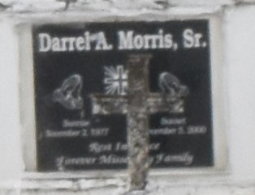

GRAMERCY - Darrel A. Morris Sr., 23, a native and resident of Lutcher, diedDec. 5. He was the father of Jaya and Jai Lewis, DaRont'e Landry and DarrelMorris Jr.
He was also the son of son of Darrel Johnson Sr. and Carolyn Morris andbrother of Kevin Johnson, Annette Greenwood, Tammy Sylvan, Wendell Sutherland, Rose Jenkins, Grace Brooks and Catherine, Darrel Jr., Corneliusand Damon Morris.
Services are today at noon at Golden Grove Baptist Church, Gramercy, with interment at Antioch Cemetery, Paulina. Visitation starts at 11 a.m.

L'Observateur (La Place, LA)
Saturday, December 9, 2000

