Curley Parker
February 15, 1926 – October 1, 2001

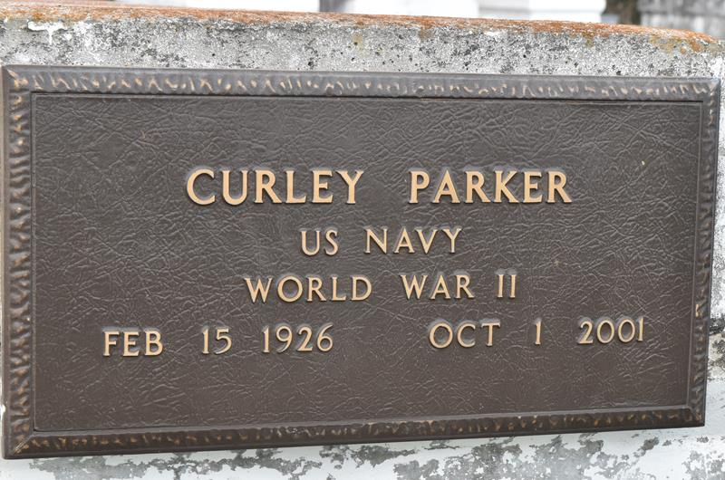

PAULINA - Curley "Curt" Parker, 75, a native of Fayette, Miss., and resident of Paulina for many years, died Oct. 1. He was the husband of the late Clara Kirklin Parker and father of Stella Johnson, Robyn Gregoire, Alvin Williams and Michael, Stephone and Curley Parker Jr.
He was the son of the late Will and Lucille Parker Green and the brother of four brothers and two sisters.
He is survived by 11 grandchildren and five great-grandchildren.
Services are today at 11 a.m. at St. Matthew Baptist Church, Paulina, with interment at Antioch Cemetery, Paulina. Visitation starts at 9 a.m.

L'Observateur (La Place, LA)
Tuesday, October 9, 2001

