Keith Rixner, Sr.
December 9, 1967 – October 23, 2016

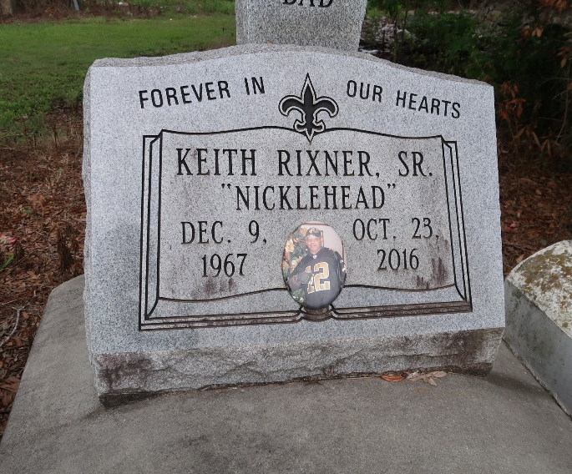

Keith "Nickle Head" Rixner Sr. at the age of 48 yrs. departed this earthly life on Sunday October 23, 2016.
Beloved son of the late Eunice and Godfrey Rixner Sr. Beloved Husband of Gevonia Rixner. Loving father of Keith Rixner Jr., Jamie Robinson, and Jonae Robinson. Grandfather of Djwanna Edward, Duanielle Edward and Dyan Edward. Brother of Michael (Lilac), Clyde (Mabel), Danny Ray (Angela), Kenneth Murray, Clay (Marba), Delton, Donald Rixner Sr., Claudia Williams (Late Husband Ralph), Lloyd, Anthony Ferdinand, and Alfred Bourgeois. Son-in-law of Judy Robinson and the late James Robinson Sr. Grand-son-in-law of Vivian Braxton. Brother-in-law of Garland, Gaylin and Gayle Robinson. Also survived by a host of aunts, uncles, nieces, nephews, other relatives and friends.
Keith was preceded in death by his parents Eunice and Godfrey Rixner Sr.; siblings Godfrey Rixner Jr., Lionel Rixner, Michelle Warren, Clyde Ferdinand; Brothers-in-law Guazzarr and James Robinson Jr. and Ralph Williams.
Pastors, Officers and Members of First Community Antioch Baptist Church of Lutcher, La., St. Matthew Baptist Church of Paulina, La., St. Mark Baptist Church of Mt. Airy, La. and all neighboring churches are invited to attend the home going celebration on Saturday October 29, 2016 at 11:00am at the First Community Antioch Baptist Church, 10860 Hwy. 3125, Lutcher, La. The Host Pastor is Pastor Ferdinand Gaines Jr.; Pastor Herman Clayton is officiating. Interment in Antioch Cemetery of Paulina, La. Visitation will be at First Community Antioch from 9:00am until service time. Bardell's Mortuary of Mt. Airy, La in charge. Information: 985-535-6837.

The New Orleans Advocate (LA)
Oct. 26 to Oct. 29, 2016

