Claudia (Aubert) Robertson
December 2, 1950 – November 5, 2012

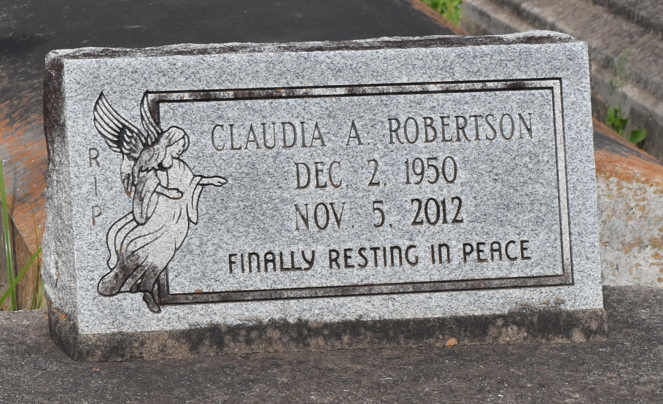

A native of Lutcher and a resident of New Orleans. She died in Metairie on Monday, Nov. 5, 2012. She was 61.
Visiting at First Community Antioch B.C., Highway 3125, Lutcher, Wednesday, Nov. 14, 2012 from 9:30 a.m. until religious services at 11 a.m. Rev. Ferdinand Gaines, Jr., Pastor, Minister Lawrence Robertson, Jr., officiating. Interment in Antioch B.C., Cemetery, Paulina.
Survived by husband, Lawrence Robertson, Sr.; three sons, Dwayne Robertson and wife, Rejean, Minister Lawrence Robertson, Jr., and Coey Robertson; four sisters, Octavia Bright and husband, Raymond, Lilly Francis and husband, Lynval, Jackie Michaels and Jennifer Thompson; six brothers, Lloyd Ricky Jackson, Robert Aubert and wife, Sharon, Tremille Aubert and wife, Natalie, Alvin Aubert and wife, Deanna, Gerald and Calvin Aubert; sisters-in-law, Phyllis, Elke and Devaka Robertson, Lattie Mason and Anita Aubert; and eight grandchildren, one great-grandchild, neices, nephews, cousins, other relatives and friends. Preceded in death by parents, Louis Aubert, Sr. and Hazel Garrison Aubert; and brother, Louis Aubert, Jr. Brazier-Watson Funeral Home in charge of arrangements. Visit us at www.brazierwatson.com to sign guest book.
The Advocate, Baton Rouge, Louisiana
Nov. 9 to Nov. 13, 2012

