Ernest M. Robertson Jr.
July 7, 1937 – January 30, 2005

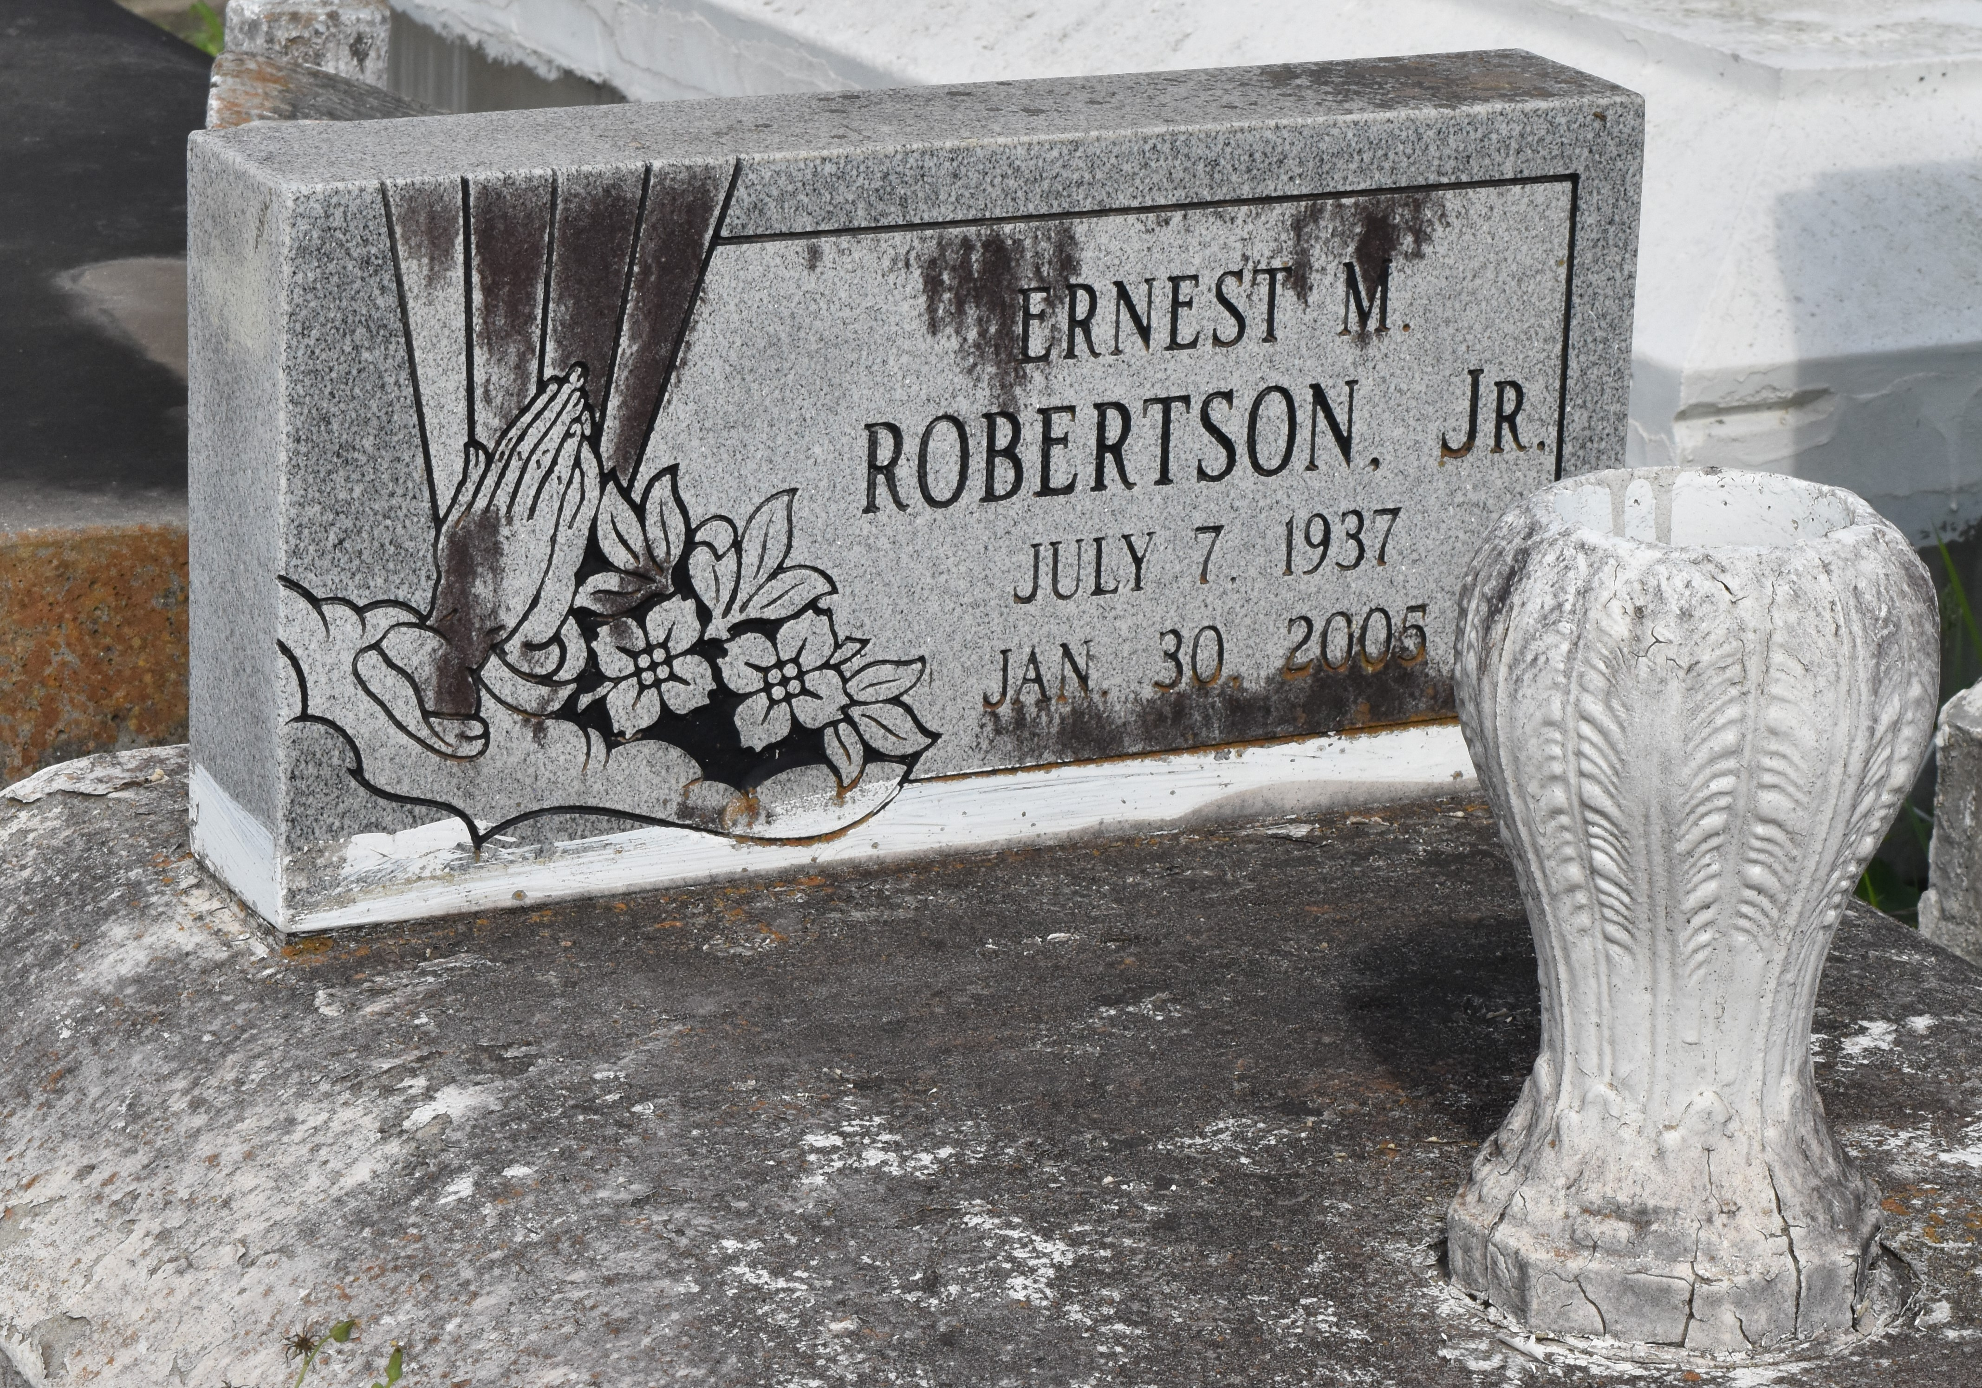

Ernest Robertson, Jr. at River Parishes Hospital, Laplace, LA at 12:45 p.m., Sunday, January 30, 2005. Son of Annie B. Marcel Robertson of Lutcher, LA and the late Ernest Robertson, Sr. Husband of Idola Porter Robertson of Paulina, LA. Father and father-in-law of Pamela and Ralph Tureaud, Jr., Patricia Johnson, Paulette and Fred Duperclay, Jr., Paul, James and Tony and Tena Porter. Foster father of Taraneka Boudreaux. Brother and brother-in-law of Laddie Mason, Nettie Kirklin, Betty and Ronnie Griffin, Jeanetta and Larry Benn, Lawrence and Claudia Robertson, Dave and Phyllis, Jackie and Elke, James and Deveka, Henry and Eddie Robertson. Nephew of Geraldine Harris, Anna Lee Bourgeois and Rosemary Long. Also survived by 22 grandchildren, 2 great-grandchildren, nieces, nephews, cousins, other relatives and friends. Age 67. Visiting at First Community Antioch Baptist Church, Highway 3125, Lutcher, LA., Saturday, February 5, 2005 from 9:30 a.m. until religious services at 11:00 a.m. Conducted by the Rev. Ferdinand Gaines, Jr. Interment in Antioch Baptist Church Cemetery, Paulina, La. BRAZIER WATSON FUNERAL HOME in charge of arrangements.
The Times-Picayune, New Orleans, Louisiana
February 5, 2005

