James Robertson
October 3, 1953 – May 5, 2008

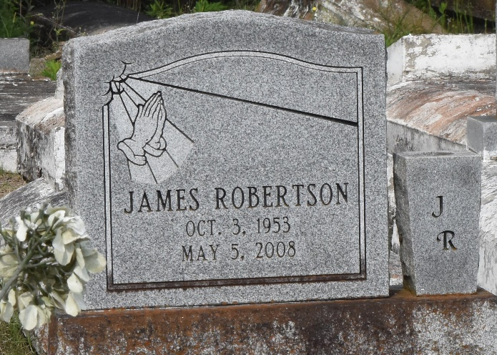

James (Snag) Robertson at River Parishes Hospital in LaPlace, LA, at 9:45 P.M., Monday, May 5, 2008. Son of the late Ernest Robertson, Sr. and Annie B. Marcel Robertson. Husband of Devaki Williams Robertson of Gramercy, LA. Father and father-in-law of Jarrad (LaToya), Jamie (Ashley), Joshua and Jonathan Robertson. Brother of Laddie Mason, Nettie Kirklin, Betty Griffin, Jeanette Benn, Jackie, Eddie, Lawrence Robertson, Sr., and the late Henry, Dave and Ernest Robertson, Jr. Brother-in-law of Tyrone and Carolyn, Ralph and Claudia, Bruce and Linda, Tommy and Darlene and Joseph and Lula Williams, Jr., Phyllis and Elka Robertson, Abbilane Bell, Fred Kirklin, Ronnie Griffin, Sr., Larry Benn and the late Idola Robertson. Also survived by four grandchildren, nieces, nephews, cousins, aunts, uncles, other relatives and friends, including Christopher Johnson, Gregory White and Kerry Robertson. Age 54.
Visiting at New Zion Full Gospel Baptist Church, Gramercy, LA on Saturday, May 10, 2008 from 9:30 A.M. until Religious Services at 11:00 A.M., conducted by the Rev. Emil D. Michell. Interment in Antioch Baptist Church Cemetery, Paulina, LA. Brazier-Watson Funeral Home in charge of arrangements.

The Times-Picayune, New Orleans, Louisiana
May 9, 2008

