Leo Robinson Sr.
August 13, 1922 – May 13, 2010

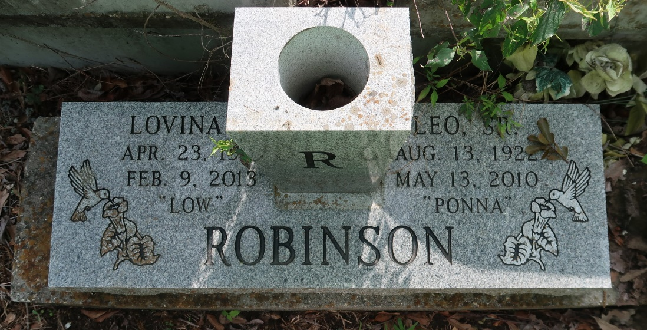

Leo Robinson Sr., a native of Paulina, LA, passed away May 13, 2010 at age 87. He was a great carpenter in the River Parish area. He leaves behind his wife, Lovina B. Robinson (Lutcher, LA), three daughters, nine sons, two step-sons, four daughters-in-law, three sons-in-law, thirty one grandchildren, and twenty nine great-grandchildren. He leaves one sister Deloris Smith (CA), as well as a host of nieces and nephews. He will always be remembered for his love, great personality, and beautiful carpentry work.

A Memorial Service will be held on Wednesday, May 19, 2010 at Bot's Place, 2810 W. Airline Hwy., Reserve, LA, at 12:00 noon. Relatives and friends are invited to attend.

The Times-Picayune, New Orleans, Louisiana
May 18, 2010

