Lovina (Bourgeois) Robinson
April 23, 19-- - February 9, 2013

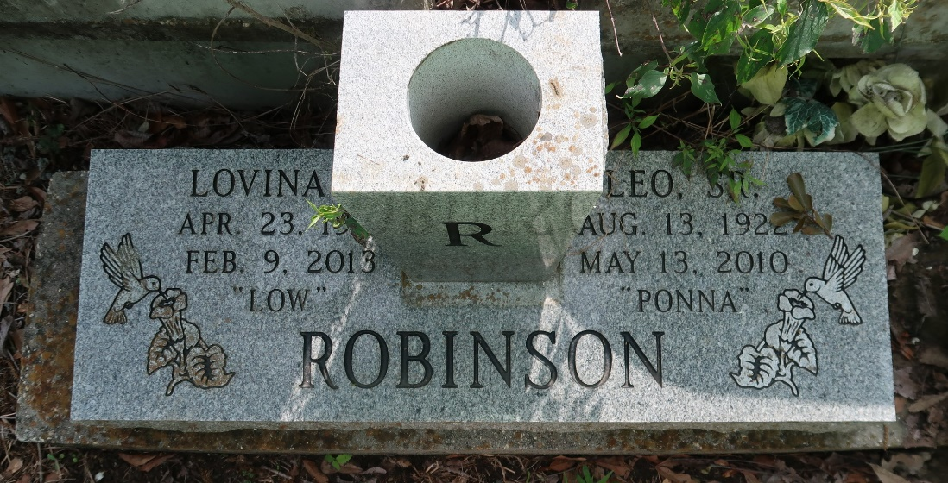

Lovina Bourgeois "Miss Low" Robinson

A native of Paulina and a resident of Lutcher. She died at 9:02 a.m., Saturday, Feb. 9, 2013 at St. James Parish Hospital in Lutcher. She died a faithful Jehovah's Witness for over 50 years. She was 80.
Visiting at Kingdom Hall of Jehovah's Witnesses, Admiral's Landing, Paulina, Sat., Feb. 16 from 1 p.m. until religious service at 3 p.m., conducted by Elder Amos Johnson. Interment in Antioch Cemetery, Paulina.
Survived by three daughters and their spouses, Yvonne and Raymond Joseph, Joan and Melvin Lewis, and Joycelyn and Freddie Howard; nine sons and their spouses, Gary Scott, John, Leon, Wayne, Leo, III., Leo, Jr. and Hilda, James and Cynthia, Lloyd and Nicole, and Larry and Geraldine Robinson; sisters, Elnora McGuffey and Dorothy Thomas; brothers, Manuel and Wilmer (Audrey) Bourgeois; sisters-in-law, Delores Cola and Beatrice Bourgeois; 29 grandchildren; 27 great grandchildren; and nieces, nephews, cousins, other relatives and friends.
Preceded in death by her parents, Isaac Bourgeois, Sr., and Edna McCormick Bourgeois; her husband, Leo Robinson, Sr.; two sons, Ronnie Ennis and Kenneth Robinson three sisters, Edna Ennis, Eunice Rixner and Rosetta Jourdan; two brothers, Samuel and Isaac Bourgeois, Jr.; and one granddaughter, Leah Robinson.
Brazier-Watson Funeral Home in charge of arrangements. Visit us at www.brazierwatson.com to sign the guest book.

The Advocate, Baton Rouge, Louisiana
Feb. 14 to Feb. 16, 2013

