Lillian (Kirkland) Ross
November 25, 1932 – May 16, 2000

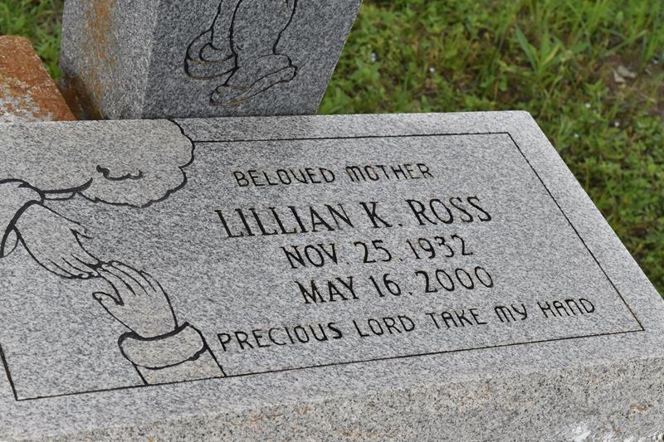

GONZALES - Lillian Kirkland Ross, 67, a native and resident of Paulina, died May 16. She was the mother of Janice Williams, Barbara Ross, Glanda Schexnayder, Leseley Smith Maureen Johnson, Joyce Turner and Robert and Ricky Ross.
She was also the sister of Robert Kirklin, Emeline Washington and Ernestine Williams.
She is also survived by 13 grandchildren and one great-grandchild.
Services are today at 11 a.m. at St. Matthew Baptist Church, Paulina, with interment at Antioch Cemetery, Paulina.

L'Observateur (La Place, LA)
Friday, May 19, 2000

