Danny Lee Russell Sr.
October 3, 1963 – December 18, 2008

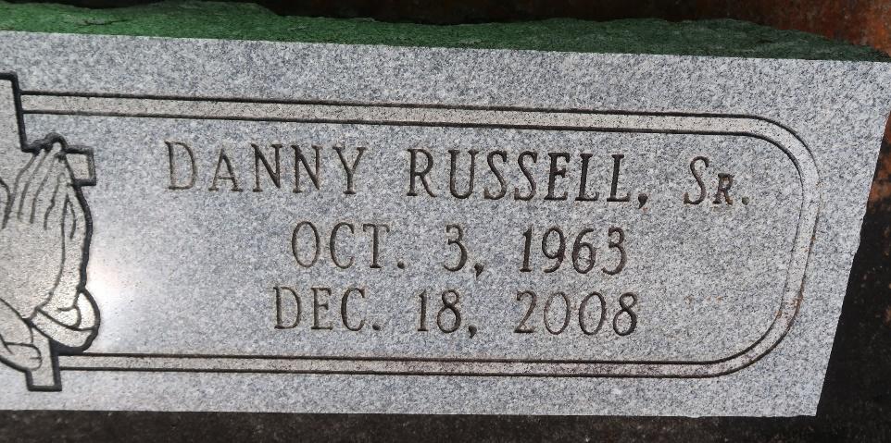

A native and resident of Paulina, he died at St. James Parish Hospital, Lutcher, at 8:15 p.m. Thursday, Dec. 18, 2008. He was 45.
Visiting at Greater Evergreen Baptist Church, La. 44, Paulina, on Tuesday, Dec. 23, from 9:30 a.m. until religious service at 11 a.m., conducted by the Rev. Nolan Albert. Interment in Antioch Cemetery, Paulina.
Survived by his mother, Margaret Marcell Russell; three children, Darren Moore and Tavia and Danny Russell Jr.; four brothers and their spouses, Donald and Debra Russell, Darron and Carla Russell and Carl and Randolph Russell; two sisters, Rosalind and spouse Albert Williams, and Claudia Russell; former wife, Tavish Johnson; grandson, nieces, nephews, cousins, aunts, uncles, sisters-in-law, brothers-in-law, other relatives and friends.
Preceded in death by his father, Royal Russell Sr.; and brother, Royal Russell Jr. Arrangements by Brazier-Watson Funeral Home.

The Advocate, Baton Rouge, Louisiana
Dec. 22, 2008

