Darron Russell
October 6, 1932 – May 23, 2010

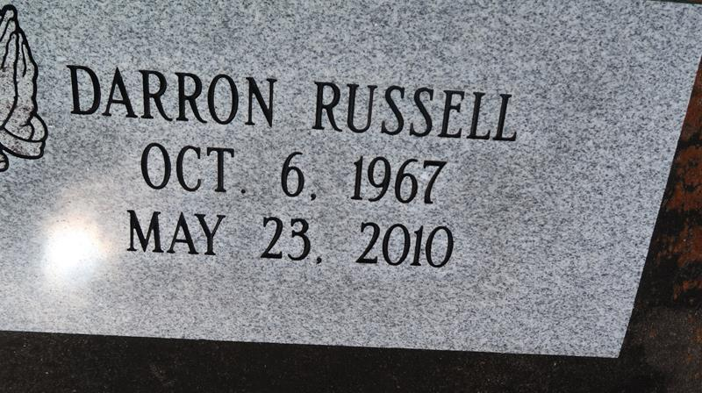

A native and resident of Paulina, he died at St. James Parish Hospital, Lutcher, Sunday, May 23, 2010, at age 42.
Visiting at Greater Evergreen Baptist Church, Paulina, Saturday, May 29, from 9:30 a.m. until religious service at 11 a.m., conducted by the Rev. Nolan Albert. Interment in Antioch Cemetery in Paulina.
Survived by his mother, Margarite Russell, of Paulina; and wife, Carla Hamilton Russell. He is the stepfather of Sharon, Takeisha, Whitley and Gregory, brother and brother-in-law of Rosalind and Albert Williams, Donald and Debra Russell, Claudia, Randolph and Carl Russell, and son-in-law of Louise and Raymond Howard. Also survived by four stepgrandchildren, aunts, uncles, nieces, nephews, cousins, other relatives and friends. Preceded in death by his father, Royal Russell Sr.; and two brothers, Danny and Royal Russell Jr.
Viewing before the funeral service only. Arrangements by Brazier-Watson Funeral Home, Donaldsonville.

Advocate, The (Baton Rouge, LA)
Friday, May 28, 2010

