Margaret (Marcell) Russell
December 24, 1932 – May 28, 2018

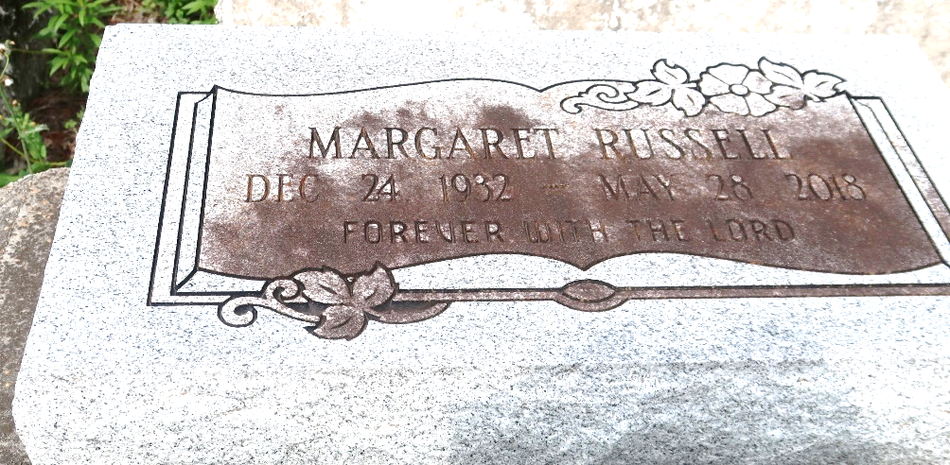

A native of Hester and a resident of Paulina. She passed away at her residence in at 12:16 p.m., Monday, May 28, 2018. She was 85.
Visiting at Evergreen Baptist Church, Highway 3125, Paulina, on Saturday, June 2, 2018, from 9:30 a.m. until religious services at 11:00 a.m. Only, conducted by the Rev. Nolan Albert. Interment in Antioch B.C. Cemetery in Paulina.
Survived by two daughters: Claudia Ann Russell and Rosalind (Albert Jr.) Williams. Three sons: Carl Anthony Russell, Randolph Russell Sr. and Rev. Donald (Deborah) Russell Sr. Her sister: Alice Marcell. Fifteen grandchildren, 24 great-grandchildren, Sisters-in-law: Dorothy Kirklin, Doretha Russell and Lillie Russell. Brother-in-law: Louis Russell Sr.; numerous nieces, nephews, cousins, other relatives and friends.
Preceded in death by her parents: Fritz Marcell and Albertha Johnson Marcell. Her husband: Royal Russell Sr. Three sons: Royal Russell Jr., Danny Russell Sr. and Darron Russell. Three brothers: Freeman Marcell Sr., Farrell Charles Marcell and Bernard Marcell.
BRAZIER-WATSON FUNERAL HOME IN CHARGE OF ARRANGEMENTS. Visit us at www.brazierwatson.com to sign our guest book.

The Advocate, Baton Rouge, Louisiana
May 31 to Jun. 2, 2018

