Marion (Bright) Russell
August 26, 1932 – November 6, 2013

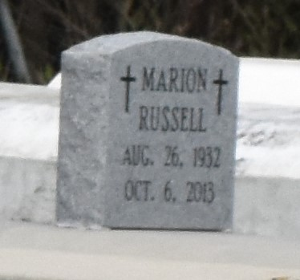

A native of Moonshine and resident of Gramercy. She died at Ochsner Kenner Hospital, at 11:41 a.m., Wednesday, Nov. 6, 2013. She was 81.
Visiting at Mt. Olive Baptist Church, Paulina, Friday, Nov. 15, 2013, from 9:30 a.m. until religious services at 11:00 a.m. conducted by the Rev. Oscar Nelson, Jr. Interment in Antioch B.C. cemetery in Paulina.
Survived by four sons and their spouses, Ronald and Donna Russell, Ernest, III and companion, Alice, Mark and wife Carisa, and Lance Johnson and companion Shannon Johnson. Seven sisters and their spouses, Dorothy and Wilbert Williams, Rosemary Lucus, Geneva and Charles Crosby, Josephine and Benjamin Smith, Albertina and Lawrence Scott, Grace Ann and Andrew Howard and Diane Wilson. Her brother, Willie Lucus and wife Linda. Sisters in law, Dorothy Kirklin, Henrietta, Lillie Mae, Margaret and Bertha Russell. A brother-in-law, Louis Russell, Sr. Numerous grandchildren, nieces, nephews, cousins, other relatives and friends.
Preceded in death by her parents, Victor Bright and Louise Lucus and Richard Lucus, whom he reared. Two sisters, Hilda Dumas and Yvonne Lucus and two brothers, Horace and Richard Lucus, Jr. Sisters in law, Gloria Keller, Rose Dupard and Dorothy and Ida Russell, and brothers in law, Mack, Raymond and Royal Russell, Sr.
Brazier-Watson Funeral Home in charge of arrangements. Visit us at www.brazierwatson.com to sign guestbook.

The Advocate, Baton Rouge, Louisiana
Nov. 13 to Nov. 14, 2013

