Royal Russell Sr.
November 14, 1928 – December 25, 2000

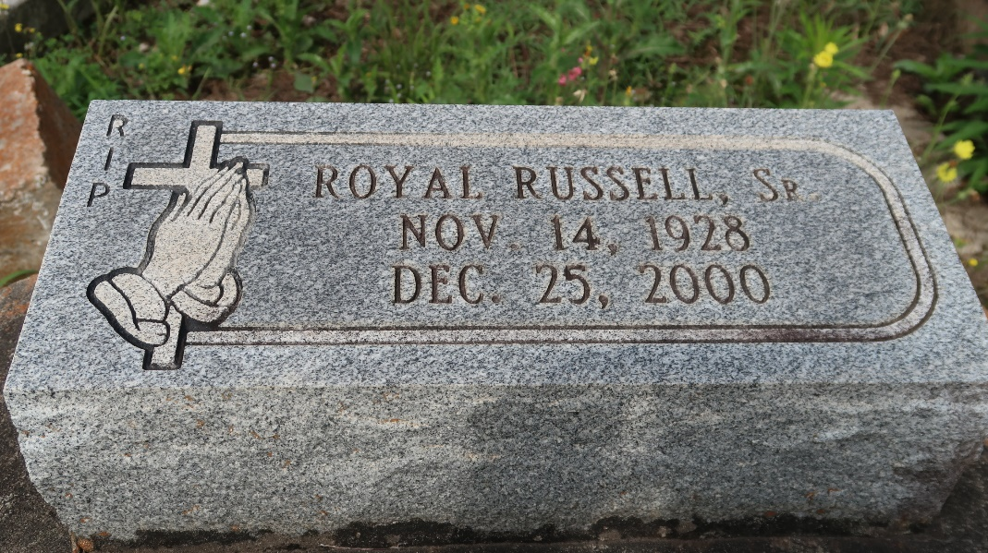

Royal Russell Sr., 72, a native and resident of Paulina, died Dec. 25, 2000.
He was the husband of Margaret Russell and father of Rosalind Williams, Claudia, the Rev. Donald, Randy, Danny, Carl, Darron and the late Royal Russell Jr.
He was the son of the late Ernest Sr. and Louvenia Davis Russell and brother of Dorothy Kirklin, Henrietta, Ernest Sr. and Louis Sr. Russell and thelate Gloria Keller, Rosanna Dupard and Jeanetta, Dorthy, Velma, Mack and Raymond Russell. He is also survived by 17 grandchildren and five great-grandchildren.
Services were Dec. 28 at First Community Antioch Baptist Church, Lutcher, with interment at the church cemetery.

Unknown source

