Brandon George Scott
August 20, 1967 – April 10, 2022

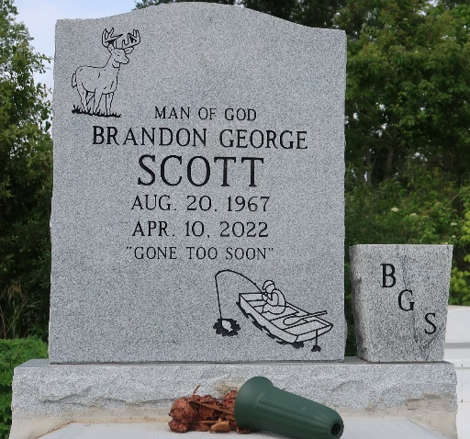

Brandon George Scott transitioned to his Heavenly Home to be with his Heavenly Father, on Sunday, April 10, 2022. Brandon is now absent from the body, but present with the Lord.
He was the son of the Late George and Emily Zeno Scott of Lutcher, La. Brandon accepted Christ at an early age and grew up in the admonition of the Lord. Brandon was educated in the St. James Parish School System. He attended Lutcher Elementary, Lutcher Junior High and graduated from Lutcher High School in 1985. After graduation, he attended Southern University of Baton Rouge, La with a degree in Electrical Engineering. He acquired a job with British Petroleum, later becoming Alliance Refinery, for 30 plus years. Brandon married Nicole Batiste on June 23, 2006, and remarried August 20, 2018. Brandon had three sons of his own: Jaris Scott (Samantha), of Prairieville, La., LonDres' Johnson of Baton Rouge, La and Quinn Scott of Gretna, La. Brandon has one grandson, Isaiah Alexander Johnson: Three stepchildren, Brandi Clark, Rashaan Dennis and Rhyan Batiste all from Vacherie, La and one adorable Princess, Khloe Clark. She called him "Pawpaw".
Brandon was a member of the King Solomon Baptist Church of Lutcher where he served as a Deacon under the leadership of Pastor Kennard R. Scott until his death. Brandon loved God's Word and his Family. He was a Sunday School Student, Bible Class attendee and Worshipper. He also loved fishing, hunting and taking pictures of nature.
Brandon will be funeralized at the New Zion Christian Center located at 216 West Main Street, Gramercy. La. 70052 on Wednesday, April 20, 2022. Viewing will be from 8:00 – 10:00 A.M. Service will begin at 10:00 A.M. Service will be officiated by King Solomon Baptist church Family pastored by Kennard R. Scott. Remains will be deposited in the Antioch Baptist Church Cemetery, on Antioch Lane in Paulina, La.
Final care and professional services entrusted to Treasures of Life Funeral Services, 315 E. Airline Hwy., Gramercy, LA 70052.

The Times-Picayune, New Orleans, Louisiana
Apr. 17 to Apr. 20, 2022

