Catherine Ann (Joseph) Scott
January 10, 1943 – February 15, 2019

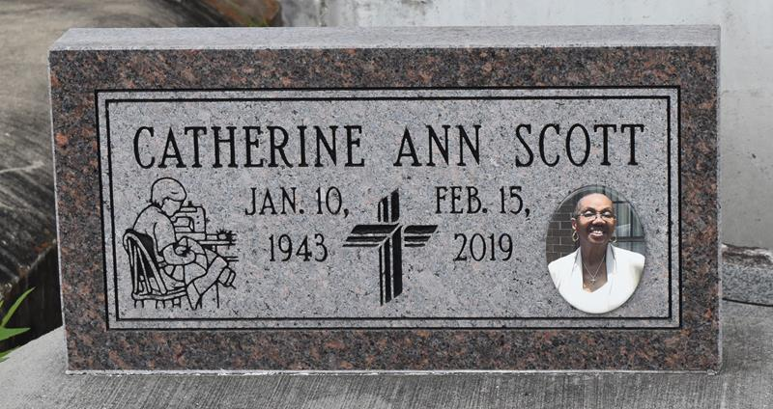

A native of Paulina and a resident of Springdale, Arkansas, Catherine Scott passed away at her residence on Friday, February 15, 2019. She was 76.
Visiting at King Solomon Baptist Church, North Courseault St., Lutcher, Monday, Feb. 25, 2019 from 9:00 a.m. until Religious Services at 10:00 a.m. conducted. by the Rev. Rowdy Scott Sr. Interment in Antioch Cemetery in Paulina.
Survived by her daughters: Odeal Scott Bedford and her husband, Terrence and Erica (Mister) Chavis. Sons: Jason Scott and Christopher and Bernard Blunt. Her sister, Millie Parker. Her brother, Leonidas Joseph Jr., 14 grandchildren, 9 great-grandchildren, numerous nieces, nephews, cousins, other relatives and friends.
Preceded in death by her husband, Elijah Scott Sr. Her parents: Leonidas Joseph Sr. and Millie Watkins Joseph, five sisters and four brothers.
BRAZIER-WATSON FUNERAL HOME IN CHARGE OF ARRANGEMENTS.

Advocate, The (Baton Rouge, LA)
Friday, February 22, 2019

