Marion (Ursin) Scott
February 15, 1928 – September 6, 2013

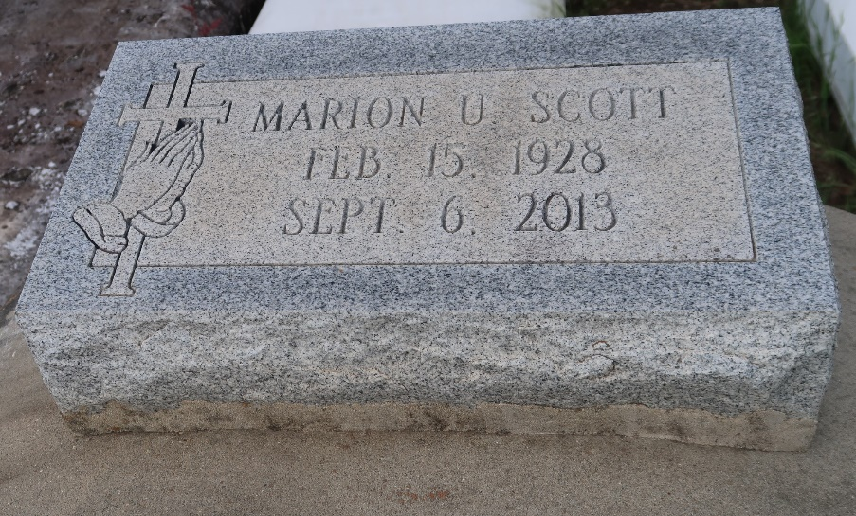

Marion Ursin Scott of Paulina, LA departed this earthly life and entered into eternal rest on Friday, September 6, 2013 at the age of 85. Beloved mother of Alex Scott, Jr. (Yvonne) of Lutcher, Carolyn Scott and Vanessa Scott of Paulina, and Brian Scott of Laplace. Loving grandmother of Kylie Scott Smith (Steve) of Columbia, MD, Kourtney Scott Wingate (Julian) and Alana Davis of Paulina, and Tylon Scott and Tyler Scott of Lutcher. Great-grandmother of Dylan Scott, Aspen Smith and Bailyn Wingate. She is also survived by a host of nieces, nephews, other relatives and friends.
She was preceded in death by her husband Alex Scott, Sr., son Ronald Scott, parents Wilfred Ursin, Sr. and Bertha Seals Ursin, siblings Charles Ursin Sr., Bertha Ursin, Wilfred Ursin, Jr., and Wade Ursin.
Relatives and friends of the family are invited to attend the Funeral Services on Tuesday, September 10, 2013 at 11:00 AM at the King Solomon Baptist Church, 2385 N. Courseault St., Lutcher, LA with Pastor Benjamin Scott Pastor officiating. Visitation at the church will begin at 9:00 AM until service time only. Interment will be in Antioch Cemetery in Paulina, LA.
Bardell's Mortuary of Mt. Airy, LA handling arrangements.

The Advocate, Baton Rouge, Louisiana
Sep. 9 to Sep. 11, 2013

