Ronald Curtis Scott
February 15, 1928 – September 6, 2013

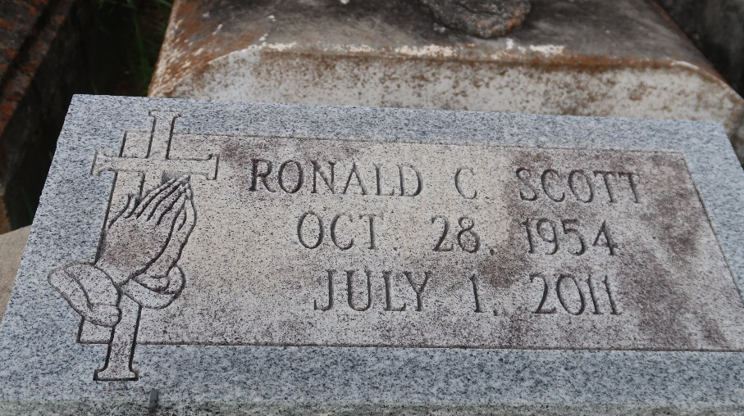

Ronald Curtis "Pee-Roy" Scott of Paulina, LA departed this earthly life and entered into eternal rest on Friday, July 1, 2011 at his residence. Age 56 years. Beloved son of Marion Ursin Scott and the late Alex Scott Sr. Loving father of Tylon and Tyler Scott. Brother of Alex (Yvonne) Scott Jr., Carolyn Scott, Vanessa Scott, and Brian Scott. Uncle of Kylie (Steve) Smith of Killeen, TX, Kourtney (Julian) Wingate and Alana Davis. Great-uncle of Dylan Scott, Aspen Smith and Bailyn Wingate. Also survived by a host of aunts, uncles, other relatives and friends.

Relatives and friends of the family, also Pastors, Offciers and Members of King Solomon Baptist Church and all neighboring churches are invited to attend the Funeral Services on Tuesday, July 5, 2011 at 11:00 AM at the King Solomon Baptist Church at 2835 N. Courseault St., Lutcher, LA. Rev. Benjamin Scott officiating. Interment in Antioch Cemetery of Paulina, LA. Visitation will be at the King Solomon Baptist Church from 9:00 AM until Service time. Bardell's Mortuary of Mt. Airy, LA in charge. Information: 985-535-6837.

The Times-Picayune, New Orleans, Louisiana
Jul. 4, 2011

