Albertha (Green) Shorty
June 11, 1950 – December 14, 2020

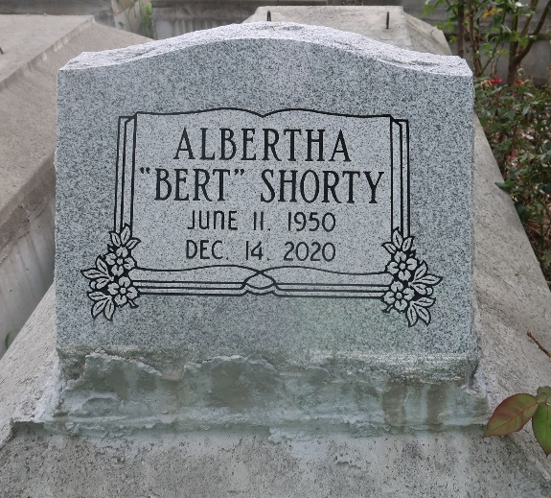

Albertha" Bert" Shorty (Green) died unexpectedly at Our Lady of the Lake Regional Medical Center on Monday December 14, 2020 in Baton Rouge, Louisiana at the age of 70.
Albertha is survived by her eight children, Leroy Shorty, Jr. (Danielle), Kevin Shorty, Sr. (Pamela), Willie Shorty, Sr. (Charlene), Samantha Shorty-Hill (Richard), Darius Shorty, Dameon Shorty (Keshia), Darrell Shorty and Shantelle Shorty her adored Maltese, Sophie, her only beloved sister Carolyn Carter, three brothers Junius Green, Jr. (Patricia), Tyrone and Kenneth White. A host of grandchildren, great-grandchildren, nieces, nephews, cousins, extended family members, other relatives and friends.
Albertha was preceded in death by her husband Royal Shorty, son David Shorty, parents Junius and Irene Wallace Green, brother Leroy "Ray" Green.
Visitation from 9am until service time (only) on Saturday, December 26, 2020 at the above name of funeral home, 134 St., Garyville, La. Private Memorial Service at 11 a.m. Rev. Nolan Albert officiating. Interment: Antioch Cemetery, Paulina, La. The family of Albertha Shorty asks to respect their mourning in private as there will be no Repast.
Due to CDC (Covid19) restrictions, seating is limited. Masks and social distancing are required. Professional services entrusted to the caring staff of Hobson Brown Funeral Home, 134 Daisy St., Garyville, La 70051, 985-535-2516.

The Times-Picayune, New Orleans, Louisiana
Dec. 24 to Dec. 26, 2020

