Joyce Ann Stafford-Patterson
March 31, 1954 – September 4, 2016

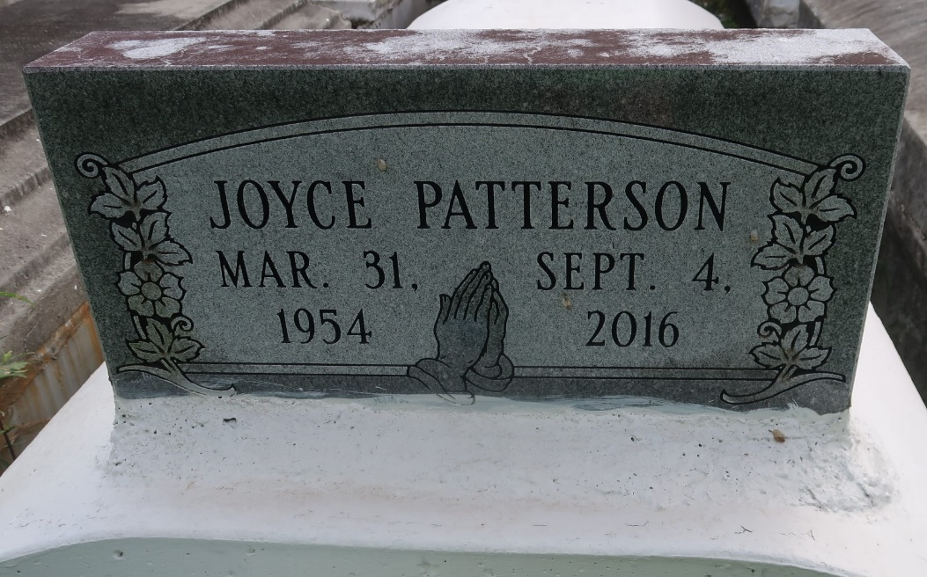

Joyce Ann Stafford - Patterson went home to be with the Lord on September 4, 2016. Loving mother of Terrance Patterson, Sr. of Alabaster, AL., Toya Patterson Joseph (Jarrin) of Gramercy, LA., Ryan Gains of Houston, TX., Terrylan Patterson of Laplace, LA.; Sister of Marva Brooks, Elmira Shaw, Kathy Inuwa, Liegy Stafford of Gramercy, LA., Marcella Linton (Paul), Herman Stafford (Nicole) of Lutcher, LA. and the late Georgia Mae Coleman and George and Esterine Lee Stafford. Survived by 14 grandchildren, 13 great grandchildren, and a host of nieces, nephews, other relatives and friends.
Lutcher High School Class of 1972, employees of Veron Provision, Gramercy Elementary School, and Louisiana Sugar Refinery are invited to attend the home going celebration on Saturday, Sept 17, 2016 for 11:00 am at the First Community Antioch Baptist Church, 10860 Hwy 3125, Lutcher, LA, Rev. Ferdinand Gaines, Jr., Pastor. Visitation begins for 9:00 am. Interment Antioch Cemetery, Paulina, La. Her final care has been entrusted to Treasures of Life Center for Funeral Services. 315 E. Airline Hwy, Gramercy, LA 70052.

Treasures of Life Funeral Services, Gramercy, Louisiana

