Audrey (Vallery) Stewart
September 3, 1940 – October 7, 2003

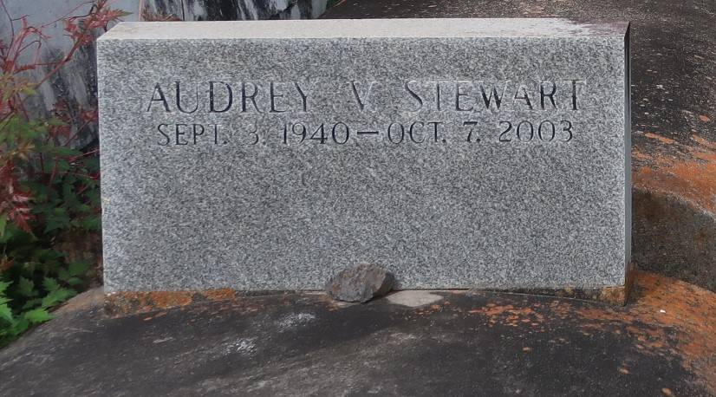

Audrey Vallery Stewart on Tuesday, October 7, 2003 at New Orleans Home and Rehab. Daughter of the late Mable and John Vallery. Wife of the late Isaac Stewart. Mother of Lance Stewart, Cynthia and Janice Stewart all of New Orleans, LA. and the late Constance Vallery Mitchell. Sister of Connie Kirklin, Laura Wadley of Convent, La., Mary V. Mullens of Baton Rouge, La., Dorothy Singleton, Tilda and Erma Vallery of New Orleans, LA, Ronald, Neal, Edmond and Leonard Vallery and the late Joseph, Alvin, Bernard, Wallace and Raymond Vallery. Mother-in-law of Armeena Stewart, of New Orleans. Also survived by (10) grandchildren, (7) great-grandchildren, a host of nieces, nephews, cousin, other relatives and friends. Age 63 years, a native of Central, LA and a resident of New Orleans for the past 35 years.
Relatives and friends of the family, also pastor, officers and members of the Mt. Olive B.C. and neighboring churches, are invited to attend the funeral services on Tuesday, October 14, 2003 at 12 o'clock (noon) from the Mt. Olive B.C., Paulina, La. Rev. Elmo Lee, officiating. Interment: Antioch Cemetery, Paulina, La. Visitation at the church after 9:00 AM on Tuesday. The Baloney Funeral Home in charge of arrangements.

The Times-Picayune, New Orleans, Louisiana
Oct. 13 to Oct. 14, 2003

